Output SPSS Validitas dan Reliabilitas Pre-Test Kuesioner Penelitian

Validitas dan Reliabilitas Variabel ICT Demands

Reliability Statistics
Cronbach's Alpha | N of Items
.878 | 6
KMO and Bartlett's Test
Kaiser-Meyer-Olkin Measure of Sampling Adequacy. |  |  |  | .789
Bartlett's Test of Sphericity |  | Approx. Chi-Square |  | 101.562
 |  | df |  | 15
 |  | Sig. |  | .000

Anti-image Matrices
 |  | ICTD1 | ICTD2 | ICTD3 | ICTD4 | ICTD5 | ICTD6
Anti-image Covariance | ICTD1 | .360 | -.134 | -.134 | .080 | -.163 | -.030
Anti-image Covariance | ICTD2 | -.134 | .327 | -.131 | -.113 | .087 | -.004
Anti-image Covariance | ICTD3 | -.134 | -.131 | .378 | -.024 | .018 | -.035
Anti-image Covariance | ICTD4 | .080 | -.113 | -.024 | .289 | -.183 | -.173
Anti-image Covariance | ICTD5 | -.163 | .087 | .018 | -.183 | .431 | -.018
Anti-image Covariance | ICTD6 | -.030 | -.004 | -.035 | -.173 | -.018 | .453
Anti-image Correlation | ICTD1 | .766ª | -.390 | -.364 | .249 | -.413 | -.074
Anti-image Correlation | ICTD2 | -.390 | .795ª | -.373 | -.367 | .232 | -.010
Anti-image Correlation | ICTD3 | -.364 | -.373 | .860ª | -.072 | .045 | -.085
Anti-image Correlation | ICTD4 | .249 | -.367 | -.072 | .729ª | -.519 | -.479
Anti-image Correlation | ICTD5 | -.413 | .232 | .045 | -.519 | .742ª | -.040
Anti-image Correlation | ICTD6 | -.074 | -.010 | -.085 | -.479 | -.040 | .864ª
a. Measures of Sampling Adequacy(MSA)

Component Matrixª
 | Component
 | 1
ICTD1 | .806
ICTD2 | .836
ICTD3 | .814
ICTD4 | .837
ICTD5 | .746
ICTD6 | .776

Validitas dan Reliabilitas Variabel ICT Resources

Reliability Statistics
Cronbach's Alpha | N of Items
.878 | 6

KMO and Bartlett's Test
Kaiser-Meyer-Olkin Measure of Sampling Adequacy. |  | .767
Bartlett's Test of Sphericity | Approx. Chi-Square | 101.122
Bartlett's Test of Sphericity | df | 15
Bartlett's Test of Sphericity | Sig. | .000

Anti-image Matrices
 |  |  |  | ICTR1 | ICTR2 | ICTR3 | ICTR4 | ICTR5 | ICTR6
Anti-image Covariance |  |  | ICTR1 | .284 | .028 | -.075 | -.180 | -.176 | .059
 |  |  | ICTR2 | .028 | .288 | -.191 | -.102 | .002 | -.066
 |  |  | ICTR3 | -.075 | -.191 | .322 | .016 | .015 | -.036
 |  |  | ICTR4 | -.180 | -.102 | .016 | .299 | .064 | -.059
 |  |  | ICTR5 | -.176 | .002 | .015 | .064 | .514 | -.236
 |  |  | ICTR6 | .059 | -.066 | -.036 | -.059 | -.236 | .574
Anti-image Correlation |  |  | ICTR1 | .731ª | .097 | -.248 | -.616 | -.462 | .146
 |  |  | ICTR2 | .097 | .771ª | -.628 | -.348 | .006 | -.163
 |  |  | ICTR3 | -.248 | -.628 | .793ª | .050 | .037 | -.083
 |  |  | ICTR4 | -.616 | -.348 | .050 | .772ª | .162 | -.143
 |  |  | ICTR5 | -.462 | .006 | .037 | .162 | .726ª | -.435
 |  |  | ICTR6 | .146 | -.163 | -.083 | -.143 | -.435 | .817ª
a. Measures of Sampling Adequacy(MSA)
Component Matrixª
 | Component
 | 1
ICTR1 | .847
ICTR2 | .844
ICTR3 | .832
ICTR4 | .849
ICTR5 | .680
ICTR6 | .697

Validitas dan Reliabilitas Variabel Digital Overload

Reliability Statistics
Cronbach's Alpha | N of Items
.948 | 7

KMO and Bartlett's Test
Kaiser-Meyer-Olkin Measure of Sampling Adequacy. |  | .808
Bartlett's Test of Sphericity | Approx. Chi-Square | 209.615
Bartlett's Test of Sphericity | df | 21
Bartlett's Test of Sphericity | Sig. | .000

Anti-image Matrices
 |  |  |  | DO1 | DO2 | DO3 | DO4 | DO5 | DO6 | DO7
Anti-image Covariance |  |  | DO1 | .198 | -.119 | .004 | -.022 | -.076 | .074 | .054
 |  |  | DO2 | -.119 | .137 | -.034 | .018 | .042 | -.055 | -.083
 |  |  | DO3 | .004 | -.034 | .230 | -.128 | .032 | .011 | -.046
 |  |  | DO4 | -.022 | .018 | -.128 | .167 | -.047 | -.058 | .042
 |  |  | DO5 | -.076 | .042 | .032 | -.047 | .142 | -.078 | -.084
 |  |  | DO6 | .074 | -.055 | .011 | -.058 | -.078 | .191 | -.009
 |  |  | DO7 | .054 | -.083 | -.046 | .042 | -.084 | -.009 | .208
Anti-image Correlation |  |  | DO1 | .747ª | -.724 | .018 | -.123 | -.456 | .379 | .269
 |  |  | DO2 | -.724 | .767ª | -.194 | .116 | .302 | -.342 | -.490
 |  |  | DO3 | .018 | -.194 | .849ª | -.653 | .174 | .054 | -.212
 |  |  | DO4 | -.123 | .116 | -.653 | .822ª | -.306 | -.326 | .226
 |  |  | DO5 | -.456 | .302 | .174 | -.306 | .800ª | -.473 | -.486
 |  |  | DO6 | .379 | -.342 | .054 | -.326 | -.473 | .846ª | -.045
 |  |  | DO7 | .269 | -.490 | -.212 | .226 | -.486 | -.045 | .831ª
a. Measures of Sampling Adequacy(MSA)
Component Matrixª
 | Component
 | 1
DO1 | .829
DO2 | .892
DO3 | .858
DO4 | .880
DO5 | .913
DO6 | .883
DO7 | .875

Validitas dan Reliabilitas Variabel Burnout

Reliability Statistics
Cronbach's Alpha | N of Items
.938 | 12

- Exhaustion

KMO and Bartlett's Test
Kaiser-Meyer-Olkin Measure of Sampling Adequacy. |  | .750
Bartlett's Test of Sphericity | Approx. Chi-Square | 55.182
Bartlett's Test of Sphericity | df | 3
Bartlett's Test of Sphericity | Sig. | .000

Anti-image Matrices
 |  | BO1 | BO2 | BO3
Anti-image Covariance | BO1 | .326 | -.118 | -.172
Anti-image Covariance | BO2 | -.118 | .385 | -.141
Anti-image Covariance | BO3 | -.172 | -.141 | .303
Anti-image Correlation | BO1 | .741ª | -.332 | -.547
Anti-image Correlation | BO2 | -.332 | .797ª | -.413
Anti-image Correlation | BO3 | -.547 | -.413 | .719ª
a. Measures of Sampling Adequacy(MSA)

Component Matrixª
 | Component
 | 1
BO1 | .920
BO2 | .902
BO3 | .928

- Mental Distance

KMO and Bartlett's Test
Kaiser-Meyer-Olkin Measure of Sampling Adequacy. |  | .740
Bartlett's Test of Sphericity | Approx. Chi-Square | 67.222
Bartlett's Test of Sphericity | df | 3
Bartlett's Test of Sphericity | Sig. | .000

Anti-image Matrices
 |  | BO4 | BO5 | BO6
Anti-image Covariance | BO4 | .384 | -.087 | -.089
Anti-image Covariance | BO5 | -.087 | .218 | -.152
Anti-image Covariance | BO6 | -.089 | -.152 | .216
Anti-image Correlation | BO4 | .861ª | -.300 | -.310
Anti-image Correlation | BO5 | -.300 | .698ª | -.698
Anti-image Correlation | BO6 | -.310 | -.698 | .697ª
a. Measures of Sampling Adequacy(MSA)

Component Matrixª
 | Component
 | 1
BO4 | .900
BO5 | .945
BO6 | .945

- Cognitive Impairment

KMO and Bartlett's Test
Kaiser-Meyer-Olkin Measure of Sampling Adequacy. |  | .701
Bartlett's Test of Sphericity | Approx. Chi-Square | 65.978
Bartlett's Test of Sphericity | df | 3
Bartlett's Test of Sphericity | Sig. | .000

Anti-image Matrices
 |  | BO7 | BO8 | BO9
Anti-image Covariance | BO7 | .188 | -.148 | -.052
Anti-image Covariance | BO8 | -.148 | .179 | -.081
Anti-image Covariance | BO9 | -.052 | -.081 | .496
Anti-image Correlation | BO7 | .652ª | -.805 | -.169
Anti-image Correlation | BO8 | -.805 | .642ª | -.273
Anti-image Correlation | BO9 | -.169 | -.273 | .903ª
a. Measures of Sampling Adequacy(MSA)

Component Matrixª
 | Component
 | 1
BO7 | .943
BO8 | .949
BO9 | .857

- Emotional Impairment

KMO and Bartlett's Test
Kaiser-Meyer-Olkin Measure of Sampling Adequacy. |  | .660
Bartlett's Test of Sphericity | Approx. Chi-Square | 29.779
Bartlett's Test of Sphericity | df | 3
Bartlett's Test of Sphericity | Sig. | .000

Anti-image Matrices
 |  | BO10 | BO11 | BO12
Anti-image Covariance | BO10 | .447 | -.139 | -.290
Anti-image Covariance | BO11 | -.139 | .731 | -.113
Anti-image Covariance | BO12 | -.290 | -.113 | .457
Anti-image Correlation | BO10 | .619ª | -.243 | -.641
Anti-image Correlation | BO11 | -.243 | .826ª | -.196
Anti-image Correlation | BO12 | -.641 | -.196 | .625ª
a. Measures of Sampling Adequacy(MSA)

Component Matrixª
 | Component
 | 1
BO10 | .889
BO11 | .752
BO12 | .882

Hasil Uji Model Pengukuran Variabel
- ICT Demands (Sebelum Respesifikasi)
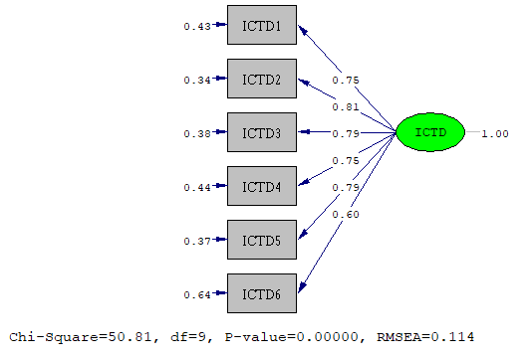
- ICT Demands (Setelah Respesifikasi)
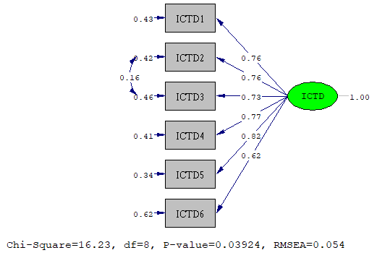

- ICT Resources (Sebelum Respesifikasi)
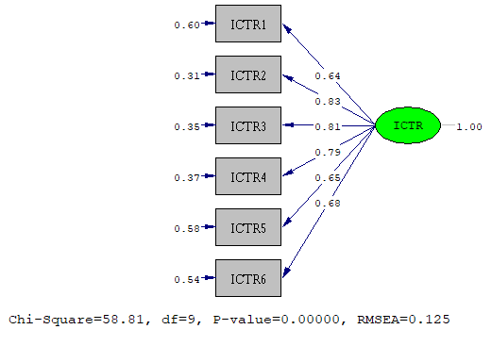
- ICT Resources (Setelah Respesifikasi)
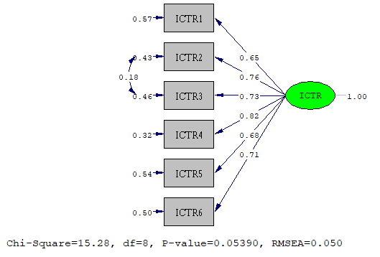

- Digital Overload (Sebelum Respesifikasi)
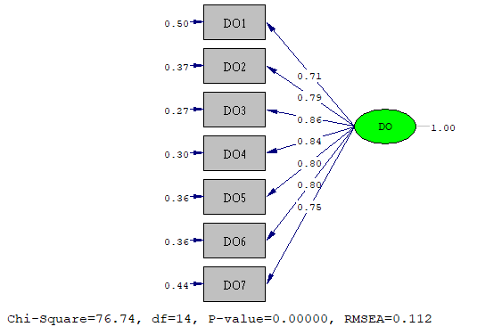
- Digital Overload (Setelah Respesifikasi)
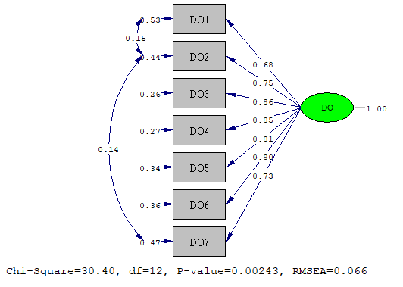

- Burnout First Order (Sebelum Respesifikasi)
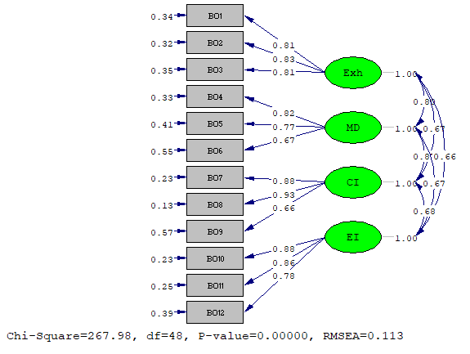
- Burnout First Order (Setelah Respesifikasi)
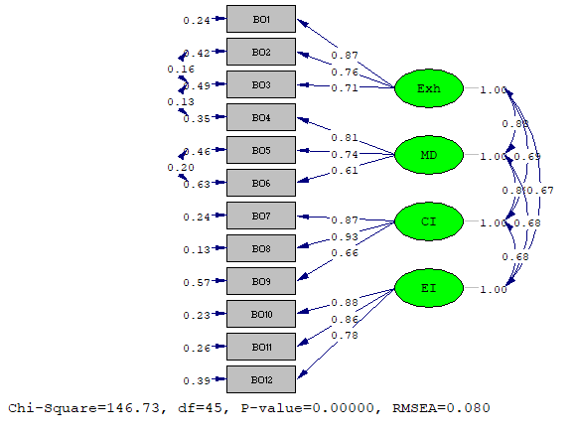

- Burnout Second Order (Sebelum Respesifikasi)
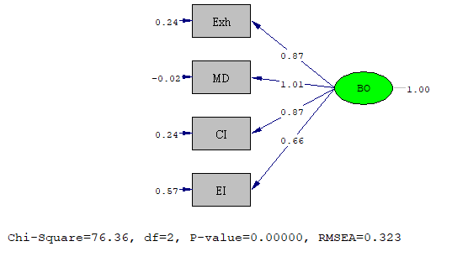
- Burnout Second Order (Setelah Respesifikasi)
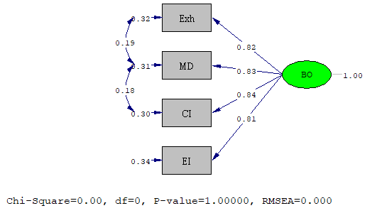
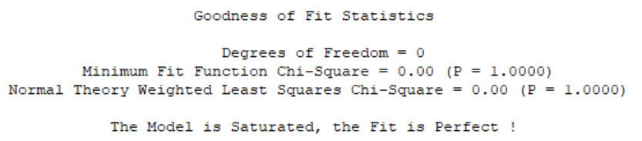

Hasil Uji Model Struktural
Standardized Solution
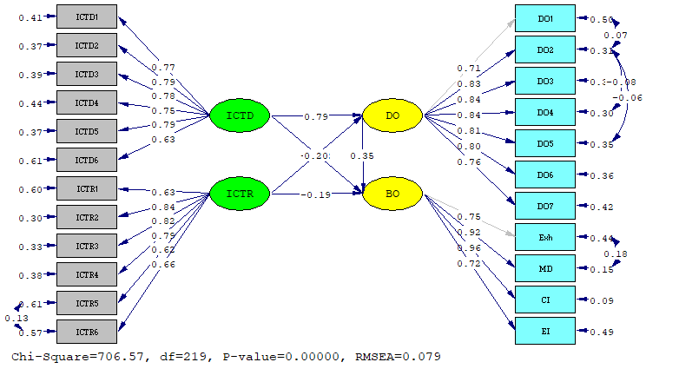

T-Value
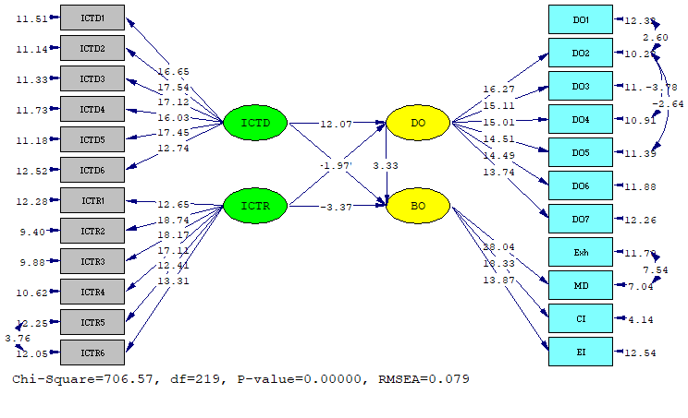

Output Analisis CB-SEM dengan Lisrel

DATE: 4/14/2025
TIME: 14:54

L I S R E L 8.80

BY

Karl G. Jöreskog & Dag Sörbom

This program is published exclusively by
Scientific Software International, Inc.
7383 N. Lincoln Avenue, Suite 100
Lincolnwood, IL 60712, U.S.A.
Phone: (800)247-6113, (847)675-0720, Fax: (847)675-2140
Copyright by Scientific Software International, Inc., 1981-2006
Use of this program is subject to the terms specified in the
Universal Copyright Convention.
Website: www.ssicentral.com

The following lines were read from file E:\Jurnal1\Jurnal1_UjiHipoRe.spl:

Raw Data from file 'E:\Jurnal1\AllLatenScore_Jurnal1.PSF'

Sample Size = 358
Latent Variables ICTD ICTR DO BO
Relationships
ICTD1-ICTD6 = ICTD
ICTR1-ICTR6 = ICTR
DO1-DO7 = DO
Exh MD CI EI = BO
DO = ICTD ICTR
BO = DO ICTD ICTR
SET ERROR COVARIANCE FROM DO2 AND DO1 FREE
SET ERROR COVARIANCE FROM DO4 AND DO2 FREE
SET ERROR COVARIANCE FROM DO5 AND DO2 FREE
SET ERROR COVARIANCE FROM MD AND Exh FREE
SET ERROR COVARIANCE FROM ICTR6 AND ICTR5 FREE
NUMBER OF DECIMALS = 4
OPTIONS SS SC EF RS ND = 4 AD=OFF
Path Diagram
End of Problem

Sample Size = 358

Covariance Matrix

DO1 DO2 DO3 DO4 DO5 DO6
-------- -------- -------- -------- -------- --------
DO1 2.7785
DO2 1.6941 2.4277
DO3 1.3909 1.4801 1.9855
DO4 1.3989 1.3267 1.4656 1.9514
DO5 1.1468 1.1524 1.1648 1.2535 1.5315
DO6 1.3277 1.4332 1.4378 1.3350 1.1900 2.1718
DO7 1.2176 1.6505 1.3906 1.3128 1.1416 1.4870
Exh 0.6911 0.7563 0.6774 0.6342 0.5583 0.7768
MD 0.7413 0.7675 0.6280 0.6508 0.5828 0.7034
CI 0.8007 0.7813 0.6327 0.6772 0.5521 0.6659
EI 0.7143 0.6018 0.6825 0.7159 0.5770 0.6836
ICTD1 1.3334 1.4586 1.2309 1.1311 1.0766 1.3007
ICTD2 1.4165 1.5840 1.1904 1.1513 1.0304 1.3939
ICTD3 1.4247 1.5460 1.2180 1.1149 0.9666 1.3276
ICTD4 1.3538 1.4407 1.1979 1.0332 0.9115 1.3854
ICTD5 1.4887 1.5888 1.3765 1.2731 1.1334 1.6335
ICTD6 1.4295 1.2326 0.9302 0.9626 0.8984 1.0334
ICTR1 -0.1719 -0.2756 -0.1814 -0.1938 -0.2089 -0.3045
ICTR2 -0.3784 -0.3673 -0.3396 -0.3180 -0.2821 -0.4513
ICTR3 -0.4777 -0.4774 -0.3329 -0.3336 -0.3143 -0.4375
ICTR4 -0.3765 -0.4110 -0.2813 -0.3269 -0.3400 -0.4103
ICTR5 -0.2097 -0.1956 -0.2511 -0.2721 -0.2861 -0.3075
ICTR6 -0.3206 -0.2660 -0.2742 -0.2834 -0.2642 -0.3484

Covariance Matrix

DO7 Exh MD CI EI ICTD1
-------- -------- -------- -------- -------- --------
DO7 2.4687
Exh 0.7443 1.0000
MD 0.6867 0.8752 1.0000
CI 0.6162 0.6899 0.8756 1.0000
EI 0.5637 0.6688 0.6761 0.6831 1.0000
ICTD1 1.2137 0.7423 0.7642 0.7253 0.5691 2.5583
ICTD2 1.4928 0.8005 0.8011 0.7493 0.6325 1.7528
ICTD3 1.7408 0.7119 0.6919 0.6542 0.5835 1.4932
ICTD4 1.3388 0.6538 0.6434 0.6554 0.5464 1.4841
ICTD5 1.3005 0.8090 0.7858 0.7512 0.6862 1.6882
ICTD6 0.8942 0.4513 0.5099 0.5891 0.5111 1.1909
ICTR1 -0.2248 -0.1730 -0.1850 -0.1906 -0.1928 -0.2425
ICTR2 -0.3046 -0.2399 -0.2540 -0.2624 -0.2546 -0.4363
ICTR3 -0.3238 -0.2874 -0.2990 -0.2800 -0.2247 -0.4612
ICTR4 -0.3172 -0.2413 -0.2351 -0.2174 -0.2189 -0.3418
ICTR5 -0.1848 -0.1651 -0.1620 -0.1694 -0.1879 -0.3655
ICTR6 -0.2204 -0.2124 -0.2282 -0.2489 -0.2436 -0.3116

Covariance Matrix

ICTD2 ICTD3 ICTD4 ICTD5 ICTD6 ICTR1
-------- -------- -------- -------- -------- --------
ICTD2 3.0370
ICTD3 2.0715 2.7398
ICTD4 1.6124 1.5421 2.7533
ICTD5 1.9010 1.7683 1.9704 3.1983
ICTD6 1.1691 1.1109 1.1757 1.3309 2.2350
ICTR1 -0.3606 -0.1759 -0.2343 -0.2242 -0.1884 0.4975
ICTR2 -0.3759 -0.3009 -0.4369 -0.4737 -0.3774 0.2768
ICTR3 -0.3640 -0.2988 -0.4542 -0.4856 -0.3468 0.2596
ICTR4 -0.3000 -0.2241 -0.3770 -0.3864 -0.3098 0.2745
ICTR5 -0.2204 -0.1746 -0.2781 -0.2922 -0.2094 0.1995
ICTR6 -0.2224 -0.1631 -0.3075 -0.2869 -0.1821 0.2284

Covariance Matrix

ICTR2 ICTR3 ICTR4 ICTR5 ICTR6
-------- -------- -------- -------- --------
ICTR2 0.5616
ICTR3 0.4398 0.6297
ICTR4 0.3276 0.3573 0.5024
ICTR5 0.2455 0.2478 0.2567 0.4354
ICTR6 0.2987 0.2912 0.2972 0.2649 0.5454

Number of Iterations = 46

LISREL Estimates (Maximum Likelihood)

Measurement Equations

DO1 = 1.1764*DO, Errorvar.= 1.3946 , R² = 0.4981
(0.1132)
12.3194

DO2 = 1.2909*DO, Errorvar.= 0.7516 , R² = 0.6892
(0.07934) (0.07309)
16.2707 10.2836

DO3 = 1.1809*DO, Errorvar.= 0.5909 , R² = 0.7024
(0.07816) (0.05190)
15.1094 11.3870

DO4 = 1.1675*DO, Errorvar.= 0.5883 , R² = 0.6985
(0.07778) (0.05393)
15.0103 10.9082

DO5 = 0.9984*DO, Errorvar.= 0.5346 , R² = 0.6509
(0.06881) (0.04693)
14.5097 11.3917

DO6 = 1.1817*DO, Errorvar.= 0.7753 , R² = 0.6430
(0.08158) (0.06526)
14.4852 11.8799

DO7 = 1.1929*DO, Errorvar.= 1.0458 , R² = 0.5764
(0.08681) (0.08533)
13.7408 12.2563

Exh = 0.7517*BO, Errorvar.= 0.4350 , R² = 0.5650
(0.03719)
11.6956

MD = 0.9200*BO, Errorvar.= 0.1537 , R² = 0.8463
(0.03281) (0.02184)
28.0407 7.0361

CI = 0.9563*BO, Errorvar.= 0.08549 , R² = 0.9145
(0.05217) (0.02066)
18.3300 4.1373

EI = 0.7167*BO, Errorvar.= 0.4863 , R² = 0.5137
(0.05167) (0.03877)
13.8726 12.5442

ICTD1 = 1.2261*ICTD, Errorvar.= 1.0551 , R² = 0.5876
(0.07362) (0.09164)
16.6538 11.5132

ICTD2 = 1.3839*ICTD, Errorvar.= 1.1219 , R² = 0.6306
(0.07892) (0.1007)
17.5360 11.1426

ICTD3 = 1.2930*ICTD, Errorvar.= 1.0681 , R² = 0.6102
(0.07554) (0.09428)
17.1157 11.3289

ICTD4 = 1.2386*ICTD, Errorvar.= 1.2192 , R² = 0.5572
(0.07724) (0.1039)
16.0343 11.7317

ICTD5 = 1.4155*ICTD, Errorvar.= 1.1947 , R² = 0.6265
(0.08111) (0.1068)
17.4508 11.1819

ICTD6 = 0.9387*ICTD, Errorvar.= 1.3538 , R² = 0.3943
(0.07368) (0.1081)
12.7402 12.5227

ICTR1 = 0.4444*ICTR, Errorvar.= 0.3000 , R² = 0.3970
(0.03513) (0.02443)
12.6499 12.2783

ICTR2 = 0.6279*ICTR, Errorvar.= 0.1674 , R² = 0.7020
(0.03351) (0.01782)
18.7382 9.3950

ICTR3 = 0.6514*ICTR, Errorvar.= 0.2054 , R² = 0.6738
(0.03585) (0.02079)
18.1709 9.8804

ICTR4 = 0.5586*ICTR, Errorvar.= 0.1904 , R² = 0.6210
(0.03264) (0.01794)
17.1115 10.6153

ICTR5 = 0.4106*ICTR, Errorvar.= 0.2668 , R² = 0.3873
(0.03310) (0.02178)
12.4078 12.2525

ICTR6 = 0.4853*ICTR, Errorvar.= 0.3100 , R² = 0.4317
(0.03646) (0.02573)
13.3091 12.0472

Error Covariance for DO2 and DO1 = 0.1770
(0.06820)
2.5952

Error Covariance for DO4 and DO2 = -0.1660
(0.04394)
-3.7784

Error Covariance for DO5 and DO2 = -0.1082
(0.04091)
-2.6446

Error Covariance for MD and Exh = 0.1837
(0.02436)
7.5403

Error Covariance for ICTR6 and ICTR5 = 0.06567
(0.01748)
3.7567

Structural Equations

DO = 0.7856*ICTD - 0.1205*ICTR, Errorvar.= 0.2790 , R² = 0.7210
(0.06507) (0.04345) (0.04389)
12.0723 -2.7736 6.3559

BO = 0.3454*DO + 0.2009*ICTD - 0.1867*ICTR, Errorvar.= 0.5898 , R² = 0.4102
(0.1037) (0.1020) (0.05537) (0.07457)
3.3320 1.9688 -3.3724 7.9095

Reduced Form Equations

DO = 0.7856*ICTD - 0.1205*ICTR, Errorvar.= 0.2790, R² = 0.7210
(0.06507) (0.04345)
12.0723 -2.7736

BO = 0.4722*ICTD - 0.2284*ICTR, Errorvar.= 0.6231, R² = 0.3769
(0.06168) (0.05702)
7.6549 -4.0050

Correlation Matrix of Independent Variables

ICTD ICTR
-------- --------
ICTD 1.0000
ICTR -0.4722 1.0000
(0.0478)
-9.8736

Covariance Matrix of Latent Variables

DO BO ICTD ICTR
-------- -------- -------- --------
DO 1.0000
BO 0.6064 1.0000
ICTD 0.8425 0.5800 1.0000
ICTR -0.4914 -0.4513 -0.4722 1.0000

Goodness of Fit Statistics

Degrees of Freedom = 219
Minimum Fit Function Chi-Square = 685.6848 (P = 0.0)
Normal Theory Weighted Least Squares Chi-Square = 706.5674 (P = 0.0)
Estimated Non-centrality Parameter (NCP) = 487.5674
90 Percent Confidence Interval for NCP = (410.9480 ; 571.7896)

Minimum Fit Function Value = 1.9207
Population Discrepancy Function Value (F0) = 1.3657
90 Percent Confidence Interval for F0 = (1.1511 ; 1.6017)
Root Mean Square Error of Approximation (RMSEA) = 0.07897
90 Percent Confidence Interval for RMSEA = (0.07250 ; 0.08552)
P-Value for Test of Close Fit (RMSEA < 0.05) = 0.0000

Expected Cross-Validation Index (ECVI) = 2.2985
90 Percent Confidence Interval for ECVI = (2.0839 ; 2.5344)
ECVI for Saturated Model = 1.5462
ECVI for Independence Model = 50.7162

Chi-Square for Independence Model with 253 Degrees of Freedom = 18059.6739
Independence AIC = 18105.6739
Model AIC = 820.5674
Saturated AIC = 552.0000
Independence CAIC = 18217.9261
Model CAIC = 1098.7577
Saturated CAIC = 1899.0271

Normed Fit Index (NFI) = 0.9620
Non-Normed Fit Index (NNFI) = 0.9697
Parsimony Normed Fit Index (PNFI) = 0.8327
Comparative Fit Index (CFI) = 0.9738
Incremental Fit Index (IFI) = 0.9738
Relative Fit Index (RFI) = 0.9561

Critical N (CN) = 141.8907

Root Mean Square Residual (RMR) = 0.08937
Standardized RMR = 0.05312
Goodness of Fit Index (GFI) = 0.8532
Adjusted Goodness of Fit Index (AGFI) = 0.8150
Parsimony Goodness of Fit Index (PGFI) = 0.6770

Fitted Covariance Matrix

DO1 DO2 DO3 DO4 DO5 DO6
-------- -------- -------- -------- -------- --------
DO1 2.7785
DO2 1.6956 2.4181
DO3 1.3892 1.5245 1.9855
DO4 1.3735 1.3412 1.3787 1.9514
DO5 1.1746 1.1807 1.1791 1.1657 1.5315
DO6 1.3902 1.5255 1.3955 1.3797 1.1799 2.1718
DO7 1.4033 1.5399 1.4087 1.3927 1.1910 1.4096
Exh 0.5362 0.5884 0.5382 0.5321 0.4551 0.5386
MD 0.6562 0.7201 0.6588 0.6513 0.5570 0.6592
CI 0.6822 0.7486 0.6848 0.6770 0.5790 0.6852
EI 0.5113 0.5611 0.5132 0.5074 0.4339 0.5136
ICTD1 1.2151 1.3335 1.2198 1.2060 1.0313 1.2207
ICTD2 1.3715 1.5050 1.3768 1.3612 1.1640 1.3777
ICTD3 1.2814 1.4062 1.2863 1.2718 1.0876 1.2872
ICTD4 1.2275 1.3470 1.2322 1.2182 1.0418 1.2331
ICTD5 1.4029 1.5394 1.4082 1.3923 1.1906 1.4092
ICTD6 0.9303 1.0209 0.9339 0.9233 0.7896 0.9346
ICTR1 -0.2569 -0.2820 -0.2579 -0.2550 -0.2181 -0.2581
ICTR2 -0.3630 -0.3983 -0.3644 -0.3603 -0.3081 -0.3646
ICTR3 -0.3766 -0.4132 -0.3780 -0.3737 -0.3196 -0.3783
ICTR4 -0.3229 -0.3543 -0.3241 -0.3205 -0.2741 -0.3244
ICTR5 -0.2374 -0.2605 -0.2383 -0.2356 -0.2015 -0.2385
ICTR6 -0.2805 -0.3078 -0.2816 -0.2784 -0.2381 -0.2818

Fitted Covariance Matrix

DO7 Exh MD CI EI ICTD1
-------- -------- -------- -------- -------- --------
DO7 2.4687
Exh 0.5437 1.0000
MD 0.6654 0.8752 1.0000
CI 0.6917 0.7188 0.8798 1.0000
EI 0.5184 0.5387 0.6594 0.6854 1.0000
ICTD1 1.2321 0.5345 0.6542 0.6801 0.5097 2.5583
ICTD2 1.3907 0.6033 0.7384 0.7676 0.5753 1.6967
ICTD3 1.2994 0.5637 0.6899 0.7171 0.5375 1.5853
ICTD4 1.2447 0.5400 0.6609 0.6870 0.5149 1.5186
ICTD5 1.4225 0.6171 0.7553 0.7851 0.5884 1.7355
ICTD6 0.9434 0.4092 0.5009 0.5207 0.3902 1.1510
ICTR1 -0.2605 -0.1508 -0.1845 -0.1918 -0.1438 -0.2573
ICTR2 -0.3681 -0.2130 -0.2607 -0.2710 -0.2031 -0.3635
ICTR3 -0.3819 -0.2210 -0.2704 -0.2811 -0.2107 -0.3771
ICTR4 -0.3274 -0.1895 -0.2319 -0.2411 -0.1807 -0.3233
ICTR5 -0.2407 -0.1393 -0.1705 -0.1772 -0.1328 -0.2377
ICTR6 -0.2845 -0.1646 -0.2015 -0.2094 -0.1570 -0.2809

Fitted Covariance Matrix

ICTD2 ICTD3 ICTD4 ICTD5 ICTD6 ICTR1
-------- -------- -------- -------- -------- --------
ICTD2 3.0370
ICTD3 1.7893 2.7398
ICTD4 1.7140 1.6014 2.7533
ICTD5 1.9588 1.8302 1.7532 3.1983
ICTD6 1.2991 1.2137 1.1627 1.3288 2.2350
ICTR1 -0.2904 -0.2713 -0.2599 -0.2970 -0.1970 0.4975
ICTR2 -0.4103 -0.3833 -0.3672 -0.4196 -0.2783 0.2791
ICTR3 -0.4256 -0.3977 -0.3809 -0.4353 -0.2887 0.2895
ICTR4 -0.3650 -0.3410 -0.3266 -0.3733 -0.2476 0.2482
ICTR5 -0.2683 -0.2507 -0.2401 -0.2744 -0.1820 0.1825
ICTR6 -0.3171 -0.2962 -0.2838 -0.3243 -0.2151 0.2157

Fitted Covariance Matrix

ICTR2 ICTR3 ICTR4 ICTR5 ICTR6
-------- -------- -------- -------- --------
ICTR2 0.5616
ICTR3 0.4090 0.6297
ICTR4 0.3507 0.3638 0.5024
ICTR5 0.2578 0.2675 0.2294 0.4354
ICTR6 0.3047 0.3161 0.2710 0.2649 0.5454

Fitted Residuals

DO1 DO2 DO3 DO4 DO5 DO6
-------- -------- -------- -------- -------- --------
DO1 0.0000
DO2 -0.0016 0.0096
DO3 0.0017 -0.0443 0.0000
DO4 0.0254 -0.0145 0.0869 0.0000
DO5 -0.0277 -0.0283 -0.0142 0.0878 0.0000
DO6 -0.0625 -0.0924 0.0423 -0.0447 0.0101 0.0000
DO7 -0.1856 0.1106 -0.0181 -0.0798 -0.0494 0.0773
Exh 0.1550 0.1679 0.1392 0.1021 0.1032 0.2381
MD 0.0851 0.0473 -0.0307 -0.0005 0.0258 0.0442
CI 0.1186 0.0327 -0.0521 0.0002 -0.0269 -0.0193
EI 0.2030 0.0408 0.1692 0.2085 0.1431 0.1700
ICTD1 0.1182 0.1251 0.0111 -0.0749 0.0453 0.0800
ICTD2 0.0450 0.0790 -0.1864 -0.2098 -0.1337 0.0162
ICTD3 0.1433 0.1398 -0.0683 -0.1568 -0.1210 0.0404
ICTD4 0.1263 0.0937 -0.0343 -0.1851 -0.1304 0.1523
ICTD5 0.0858 0.0494 -0.0317 -0.1192 -0.0573 0.2243
ICTD6 0.4991 0.2117 -0.0037 0.0393 0.1088 0.0988
ICTR1 0.0851 0.0064 0.0766 0.0612 0.0092 -0.0464
ICTR2 -0.0154 0.0310 0.0248 0.0423 0.0260 -0.0867
ICTR3 -0.1011 -0.0641 0.0451 0.0401 0.0053 -0.0592
ICTR4 -0.0536 -0.0566 0.0429 -0.0064 -0.0660 -0.0860
ICTR5 0.0277 0.0649 -0.0128 -0.0365 -0.0846 -0.0690
ICTR6 -0.0400 0.0419 0.0074 -0.0050 -0.0261 -0.0666

Fitted Residuals

DO7 Exh MD CI EI ICTD1
-------- -------- -------- -------- -------- --------
DO7 0.0000
Exh 0.2006 0.0000
MD 0.0213 0.0000 0.0000
CI -0.0755 -0.0289 -0.0042 0.0000
EI 0.0453 0.1300 0.0168 -0.0024 0.0000
ICTD1 -0.0184 0.2078 0.1100 0.0452 0.0594 0.0000
ICTD2 0.1021 0.1972 0.0627 -0.0183 0.0572 0.0560
ICTD3 0.4414 0.1482 0.0020 -0.0629 0.0460 -0.0921
ICTD4 0.0941 0.1138 -0.0175 -0.0315 0.0315 -0.0345
ICTD5 -0.1220 0.1919 0.0305 -0.0339 0.0978 -0.0474
ICTD6 -0.0491 0.0420 0.0090 0.0684 0.1208 0.0399
ICTR1 0.0358 -0.0222 -0.0004 0.0012 -0.0490 0.0147
ICTR2 0.0635 -0.0269 0.0067 0.0086 -0.0515 -0.0728
ICTR3 0.0581 -0.0665 -0.0286 0.0011 -0.0140 -0.0841
ICTR4 0.0102 -0.0519 -0.0032 0.0236 -0.0383 -0.0185
ICTR5 0.0560 -0.0258 0.0085 0.0078 -0.0551 -0.1278
ICTR6 0.0640 -0.0477 -0.0267 -0.0395 -0.0866 -0.0307

Fitted Residuals

ICTD2 ICTD3 ICTD4 ICTD5 ICTD6 ICTR1
-------- -------- -------- -------- -------- --------
ICTD2 0.0000
ICTD3 0.2822 0.0000
ICTD4 -0.1016 -0.0593 0.0000
ICTD5 -0.0578 -0.0619 0.2173 0.0000
ICTD6 -0.1300 -0.1028 0.0131 0.0021 0.0000
ICTR1 -0.0702 0.0954 0.0256 0.0728 0.0086 0.0000
ICTR2 0.0343 0.0825 -0.0697 -0.0540 -0.0991 -0.0022
ICTR3 0.0616 0.0989 -0.0732 -0.0502 -0.0581 -0.0299
ICTR4 0.0649 0.1169 -0.0503 -0.0131 -0.0622 0.0262
ICTR5 0.0479 0.0761 -0.0380 -0.0177 -0.0274 0.0170
ICTR6 0.0947 0.1332 -0.0237 0.0374 0.0330 0.0128

Fitted Residuals

ICTR2 ICTR3 ICTR4 ICTR5 ICTR6
-------- -------- -------- -------- --------
ICTR2 0.0000
ICTR3 0.0308 0.0000
ICTR4 -0.0231 -0.0066 0.0000
ICTR5 -0.0124 -0.0197 0.0274 0.0000
ICTR6 -0.0060 -0.0249 0.0261 0.0000 0.0000

Summary Statistics for Fitted Residuals

Smallest Fitted Residual = -0.2098
Median Fitted Residual = 0.0000
Largest Fitted Residual = 0.4991

Stemleaf Plot

- 2|1
- 1|9996
- 1|33332220000
- 0|99999888877777777776666666666665555555555555
- 0|444444433333333333333333322222222222221111111110000000000000000000000000+14
0|111111111111111112222223333333333333334444444444444
0|5555555556666666666667788888899999999
1|00000001111222233334444
1|5557779
2|000111224
2|8
3|
3|
4|4
4|
5|0

Standardized Residuals

DO1 DO2 DO3 DO4 DO5 DO6
-------- -------- -------- -------- -------- --------
DO1 - -
DO2 -0.1255 2.0926
DO3 0.0419 -1.6499 - -
DO4 0.6302 -1.9471 3.5198 - -
DO5 -0.7010 -3.1812 -0.5884 3.7793 - -
DO6 -1.2838 -2.8478 1.4232 -1.5150 0.3502 - -
DO7 -3.2053 2.8220 -0.5075 -2.2584 -1.4347 1.8408
Exh 2.5050 3.3039 3.0453 2.2479 2.4775 4.7698
MD 1.6611 1.2565 -0.9128 -0.0142 0.8092 1.1484
CI 2.4341 0.9499 -1.6989 0.0075 -0.9107 -0.5411
EI 3.1765 0.7652 3.5285 4.3742 3.2877 3.2617
ICTD1 1.5294 2.1183 0.2089 -1.4171 0.9144 1.3405
ICTD2 0.5563 1.2893 -3.3825 -3.8274 -2.5935 0.2607
ICTD3 1.8278 2.3457 -1.2753 -2.9409 -2.4165 0.6691
ICTD4 1.5339 1.4795 -0.6032 -3.2691 -2.4616 2.3885
ICTD5 1.0287 0.7819 -0.5579 -2.1075 -1.0776 3.4998
ICTD6 5.9624 3.2079 -0.0629 0.6665 1.9891 1.5034
ICTR1 1.7131 0.1504 1.9987 1.6096 0.2668 -1.1256
ICTR2 -0.3426 0.8849 0.7888 1.3521 0.8930 -2.4773
ICTR3 -2.0902 -1.6769 1.3159 1.1772 0.1681 -1.5569
ICTR4 -1.2020 -1.5742 1.3288 -0.2006 -2.2289 -2.4221
ICTR5 0.5940 1.6235 -0.3557 -1.0199 -2.6089 -1.7798
ICTR6 -0.7828 0.9636 0.1886 -0.1278 -0.7397 -1.5769

Standardized Residuals

DO7 Exh MD CI EI ICTD1
-------- -------- -------- -------- -------- --------
DO7 - -
Exh 3.6028 - -
MD 0.4769 - - - -
CI -1.7993 -8.5336 -4.7100 - -
EI 0.7830 6.0611 2.0175 -0.5664 - -
ICTD1 -0.2704 3.6929 2.4992 1.1039 1.0149 - -
ICTD2 1.4313 3.3135 1.3877 -0.4398 0.9209 1.2098
ICTD3 6.3873 2.5852 0.0450 -1.5390 0.7702 -2.0103
ICTD4 1.2933 1.9108 -0.3684 -0.7091 0.5102 -0.6854
ICTD5 -1.6602 3.1335 0.6536 -0.7880 1.5287 -0.9882
ICTD6 -0.6608 0.7115 0.1787 1.4119 1.9919 0.7148
ICTR1 0.7894 -0.7553 -0.0167 0.0499 -1.6268 0.3221
ICTR2 1.5983 -1.0338 0.3548 0.5123 -1.8900 -1.8521
ICTR3 1.3526 -2.3625 -1.3658 0.0582 -0.4768 -1.9736
ICTR4 0.2556 -1.9916 -0.1554 1.2619 -1.4141 -0.4646
ICTR5 1.3147 -0.9312 0.3506 0.3333 -1.9476 -2.9683
ICTR6 1.3757 -1.5766 -1.0205 -1.5690 -2.7927 -0.6531

Standardized Residuals

ICTD2 ICTD3 ICTD4 ICTD5 ICTD6 ICTR1
-------- -------- -------- -------- -------- --------
ICTD2 - -
ICTD3 6.1457 - -
ICTD4 -2.0073 -1.1864 - -
ICTD5 -1.2039 -1.3014 4.1485 - -
ICTD6 -2.3023 -1.8469 0.2151 0.0362 - -
ICTR1 -1.4361 2.0349 0.5312 1.4491 0.1859 - -
ICTR2 0.8378 2.0733 -1.6600 -1.2790 -2.2951 -0.2460
ICTR3 1.3809 2.2888 -1.6120 -1.0933 -1.2527 -2.9080
ICTR4 1.5548 2.8971 -1.1928 -0.3046 -1.4658 2.5205
ICTR5 1.0416 1.7270 -0.8395 -0.3753 -0.6296 1.2506
ICTR6 1.8915 2.7716 -0.4790 0.7274 0.6888 0.8818

Standardized Residuals

ICTR2 ICTR3 ICTR4 ICTR5 ICTR6
-------- -------- -------- -------- --------
ICTR2 - -
ICTR3 5.5824 - -
ICTR4 -3.9714 -0.9681 - -
ICTR5 -1.4787 -2.0529 2.8076 - -
ICTR6 -0.6772 -2.4440 2.5280 - - - -

Summary Statistics for Standardized Residuals

Smallest Standardized Residual = -8.5336
Median Standardized Residual = 0.0000
Largest Standardized Residual = 6.3873

Stemleaf Plot

- 8|5
- 7|
- 6|
- 5|
- 4|70
- 3|843220
- 2|99886655444433321110000
- 1|999988877776666666655554444433333222211100000
- 0|99988887777777666665555544443332221110000000000000000000000000000000
0|12222222333334445555666777777788888888999999
1|000011223333333334444444445555566667778899
2|00000111233445555568889
3|01223333555678
4|148
5|6
6|0114
Largest Negative Standardized Residuals
Residual for DO5 and DO2 -3.1812
Residual for DO6 and DO2 -2.8478
Residual for DO7 and DO1 -3.2053
Residual for CI and Exh -8.5336
Residual for CI and MD -4.7100
Residual for ICTD2 and DO3 -3.3825
Residual for ICTD2 and DO4 -3.8274
Residual for ICTD2 and DO5 -2.5935
Residual for ICTD3 and DO4 -2.9409
Residual for ICTD4 and DO4 -3.2691
Residual for ICTR3 and ICTR1 -2.9080
Residual for ICTR4 and ICTR2 -3.9714
Residual for ICTR5 and DO5 -2.6089
Residual for ICTR5 and ICTD1 -2.9683
Residual for ICTR6 and EI -2.7927
Largest Positive Standardized Residuals
Residual for DO4 and DO3 3.5198
Residual for DO5 and DO4 3.7793
Residual for DO7 and DO2 2.8220
Residual for Exh and DO2 3.3039
Residual for Exh and DO3 3.0453
Residual for Exh and DO6 4.7698
Residual for Exh and DO7 3.6028
Residual for EI and DO1 3.1765
Residual for EI and DO3 3.5285
Residual for EI and DO4 4.3742
Residual for EI and DO5 3.2877
Residual for EI and DO6 3.2617
Residual for EI and Exh 6.0611
Residual for ICTD1 and Exh 3.6929
Residual for ICTD2 and Exh 3.3135
Residual for ICTD3 and DO7 6.3873
Residual for ICTD3 and Exh 2.5852
Residual for ICTD3 and ICTD2 6.1457
Residual for ICTD5 and DO6 3.4998
Residual for ICTD5 and Exh 3.1335
Residual for ICTD5 and ICTD4 4.1485
Residual for ICTD6 and DO1 5.9624
Residual for ICTD6 and DO2 3.2079
Residual for ICTR3 and ICTR2 5.5824
Residual for ICTR4 and ICTD3 2.8971
Residual for ICTR5 and ICTR4 2.8076
Residual for ICTR6 and ICTD3 2.7716

Qplot of Standardized Residuals

3.5..........................................................................
. ..
. . .
. . .
. . .
. . .
. . x
. . x
. . x
. . *
. . *
. . *
. . *
. . * x
. . xxxx* .
N . . *x xx .
o . . x*x** .
r . . xx ** .
m . . **x .
a . . x*x* .
l . . x**x .
. . xxx* .
Q . .xxxxx .
u . *x** .
a . xxxxx .
n . x*x*. .
t . xxxx* . .
i . xxx . .
l . x*x . .
e . xx** . .
s . x xx . .
. *** . .
. * x . .
. ** . .
. x x . .
. xx . .
xx . .
x . .
x . .
x . .
. . .
. . .
. . .
. . .
-3.5..........................................................................
-3.5 3.5
Standardized Residuals

The Modification Indices Suggest to Add the
Path to from Decrease in Chi-Square New Estimate
Exh DO 30.8 0.19
MD DO 15.8 -0.10
EI DO 15.3 0.20
ICTD3 ICTR 14.4 0.29

The Modification Indices Suggest to Add an Error Covariance
Between and Decrease in Chi-Square New Estimate
DO4 DO3 11.9 0.14
DO5 DO4 14.3 0.14
DO6 DO2 12.1 -0.18
DO7 DO1 12.5 -0.24
DO7 DO2 9.3 0.18
Exh DO6 11.9 0.08
CI Exh 88.3 -0.19
CI MD 96.2 0.22
EI DO2 10.5 -0.11
EI DO3 8.9 0.09
EI Exh 48.2 0.13
EI MD 34.4 -0.09
ICTD3 DO7 58.0 0.48
ICTD3 ICTD2 37.8 0.45
ICTD5 DO6 11.8 0.20
ICTD5 DO7 11.2 -0.22
ICTD5 ICTD4 17.2 0.32
ICTD6 DO1 21.2 0.34
ICTD6 DO7 8.8 -0.20
ICTR1 ICTD2 21.2 -0.16
ICTR3 ICTR1 8.5 -0.05
ICTR3 ICTR2 31.2 0.10
ICTR4 DO5 7.9 -0.06
ICTR4 ICTR2 15.8 -0.06
ICTR5 DO5 9.1 -0.06
ICTR5 ICTD1 9.7 -0.09

Standardized Solution

LAMBDA-Y

DO BO
-------- --------
DO1 1.1764 - -
DO2 1.2909 - -
DO3 1.1809 - -
DO4 1.1675 - -
DO5 0.9984 - -
DO6 1.1817 - -
DO7 1.1929 - -
Exh - - 0.7517
MD - - 0.9200
CI - - 0.9563
EI - - 0.7167

LAMBDA-X

ICTD ICTR
-------- --------
ICTD1 1.2261 - -
ICTD2 1.3839 - -
ICTD3 1.2930 - -
ICTD4 1.2386 - -
ICTD5 1.4155 - -
ICTD6 0.9387 - -
ICTR1 - - 0.4444
ICTR2 - - 0.6279
ICTR3 - - 0.6514
ICTR4 - - 0.5586
ICTR5 - - 0.4106
ICTR6 - - 0.4853

BETA

DO BO
-------- --------
DO - - - -
BO 0.3454 - -

GAMMA

ICTD ICTR
-------- --------
DO 0.7856 -0.1205
BO 0.2009 -0.1867

Correlation Matrix of ETA and KSI

DO BO ICTD ICTR
-------- -------- -------- --------
DO 1.0000
BO 0.6064 1.0000
ICTD 0.8425 0.5800 1.0000
ICTR -0.4914 -0.4513 -0.4722 1.0000

PSI
Note: This matrix is diagonal.

DO BO
-------- --------
0.2790 0.5898

Regression Matrix ETA on KSI (Standardized)

ICTD ICTR
-------- --------
DO 0.7856 -0.1205
BO 0.4722 -0.2284

Completely Standardized Solution

LAMBDA-Y

DO BO
-------- --------
DO1 0.7057 - -
DO2 0.8302 - -
DO3 0.8381 - -
DO4 0.8358 - -
DO5 0.8068 - -
DO6 0.8019 - -
DO7 0.7592 - -
Exh - - 0.7517
MD - - 0.9200
CI - - 0.9563
EI - - 0.7167

LAMBDA-X

ICTD ICTR
-------- --------
ICTD1 0.7666 - -
ICTD2 0.7941 - -
ICTD3 0.7811 - -
ICTD4 0.7464 - -
ICTD5 0.7915 - -
ICTD6 0.6279 - -
ICTR1 - - 0.6301
ICTR2 - - 0.8378
ICTR3 - - 0.8208
ICTR4 - - 0.7880
ICTR5 - - 0.6223
ICTR6 - - 0.6571

BETA

DO BO
-------- --------
DO - - - -
BO 0.3454 - -

GAMMA

ICTD ICTR
-------- --------
DO 0.7856 -0.1205
BO 0.2009 -0.1867

Correlation Matrix of ETA and KSI

DO BO ICTD ICTR
-------- -------- -------- --------
DO 1.0000
BO 0.6064 1.0000
ICTD 0.8425 0.5800 1.0000
ICTR -0.4914 -0.4513 -0.4722 1.0000

PSI
Note: This matrix is diagonal.

DO BO
-------- --------
0.2790 0.5898

THETA-EPS

DO1 DO2 DO3 DO4 DO5 DO6
-------- -------- -------- -------- -------- --------
DO1 0.5019
DO2 0.0683 0.3108
DO3 - - - - 0.2976
DO4 - - -0.0764 - - 0.3015
DO5 - - -0.0562 - - - - 0.3491
DO6 - - - - - - - - - - 0.3570
DO7 - - - - - - - - - - - -
Exh - - - - - - - - - - - -
MD - - - - - - - - - - - -
CI - - - - - - - - - - - -
EI - - - - - - - - - - - -

THETA-EPS

DO7 Exh MD CI EI
-------- -------- -------- -------- --------
DO7 0.4236
Exh - - 0.4350
MD - - 0.1837 0.1537
CI - - - - - - 0.0855
EI - - - - - - - - 0.4863

THETA-DELTA

ICTD1 ICTD2 ICTD3 ICTD4 ICTD5 ICTD6
-------- -------- -------- -------- -------- --------
ICTD1 0.4124
ICTD2 - - 0.3694
ICTD3 - - - - 0.3898
ICTD4 - - - - - - 0.4428
ICTD5 - - - - - - - - 0.3735
ICTD6 - - - - - - - - - - 0.6057
ICTR1 - - - - - - - - - - - -
ICTR2 - - - - - - - - - - - -
ICTR3 - - - - - - - - - - - -
ICTR4 - - - - - - - - - - - -
ICTR5 - - - - - - - - - - - -
ICTR6 - - - - - - - - - - - -

THETA-DELTA

ICTR1 ICTR2 ICTR3 ICTR4 ICTR5 ICTR6
-------- -------- -------- -------- -------- --------
ICTR1 0.6030
ICTR2 - - 0.2980
ICTR3 - - - - 0.3262
ICTR4 - - - - - - 0.3790
ICTR5 - - - - - - - - 0.6127
ICTR6 - - - - - - - - 0.1348 0.5683

Regression Matrix ETA on KSI (Standardized)

ICTD ICTR
-------- --------
DO 0.7856 -0.1205
BO 0.4722 -0.2284

Total and Indirect Effects

Total Effects of KSI on ETA

ICTD ICTR
-------- --------
DO 0.7856 -0.1205
(0.0651) (0.0435)
12.0723 -2.7736
BO 0.4722 -0.2284
(0.0617) (0.0570)
7.6549 -4.0050

Indirect Effects of KSI on ETA

ICTD ICTR
-------- --------
DO - - - -
BO 0.2713 -0.0416
(0.0817) (0.0191)
3.3191 -2.1754

Total Effects of ETA on ETA

DO BO
-------- --------
DO - - - -
BO 0.3454 - -
(0.1037)
3.3320

Largest Eigenvalue of B*B' (Stability Index) is 0.119

Total Effects of ETA on Y

DO BO
-------- --------
DO1 1.1764 - -
DO2 1.2909 - -
(0.0793)
16.2707
DO3 1.1809 - -
(0.0782)
15.1094
DO4 1.1675 - -
(0.0778)
15.0103
DO5 0.9984 - -
(0.0688)
14.5097
DO6 1.1817 - -
(0.0816)
14.4852
DO7 1.1929 - -
(0.0868)
13.7408
Exh 0.2596 0.7517
(0.0779)
3.3320
MD 0.3177 0.9200
(0.0944) (0.0328)
3.3654 28.0407
CI 0.3303 0.9563
(0.0979) (0.0522)
3.3722 18.3300
EI 0.2476 0.7167
(0.0745) (0.0517)
3.3248 13.8726

Indirect Effects of ETA on Y

DO BO
-------- --------
DO1 - - - -
DO2 - - - -
DO3 - - - -
DO4 - - - -
DO5 - - - -
DO6 - - - -
DO7 - - - -
Exh 0.2596 - -
(0.0779)
3.3320
MD 0.3177 - -
(0.0944)
3.3654
CI 0.3303 - -
(0.0979)
3.3722
EI 0.2476 - -
(0.0745)
3.3248

Total Effects of KSI on Y

ICTD ICTR
-------- --------
DO1 0.9241 -0.1418
(0.0765) (0.0511)
12.0723 -2.7736
DO2 1.0141 -0.1556
(0.0732) (0.0557)
13.8570 -2.7914
DO3 0.9277 -0.1423
(0.0662) (0.0510)
14.0144 -2.7927
DO4 0.9172 -0.1407
(0.0656) (0.0504)
13.9760 -2.7924
DO5 0.7843 -0.1203
(0.0578) (0.0431)
13.5621 -2.7890
DO6 0.9283 -0.1424
(0.0687) (0.0511)
13.5091 -2.7885
DO7 0.9371 -0.1438
(0.0727) (0.0517)
12.8976 -2.7827
Exh 0.3549 -0.1717
(0.0464) (0.0429)
7.6549 -4.0050
MD 0.4344 -0.2101
(0.0537) (0.0517)
8.0886 -4.0635
CI 0.4515 -0.2184
(0.0552) (0.0536)
8.1838 -4.0754
EI 0.3384 -0.1637
(0.0447) (0.0410)
7.5688 -3.9925

Standardized Total and Indirect Effects

Standardized Total Effects of KSI on ETA

ICTD ICTR
-------- --------
DO 0.7856 -0.1205
BO 0.4722 -0.2284

Standardized Indirect Effects of KSI on ETA

ICTD ICTR
-------- --------
DO - - - -
BO 0.2713 -0.0416

Standardized Total Effects of ETA on ETA

DO BO
-------- --------
DO - - - -
BO 0.3454 - -

Standardized Total Effects of ETA on Y

DO BO
-------- --------
DO1 1.1764 - -
DO2 1.2909 - -
DO3 1.1809 - -
DO4 1.1675 - -
DO5 0.9984 - -
DO6 1.1817 - -
DO7 1.1929 - -
Exh 0.2596 0.7517
MD 0.3177 0.9200
CI 0.3303 0.9563
EI 0.2476 0.7167

Completely Standardized Total Effects of ETA on Y

DO BO
-------- --------
DO1 0.7057 - -
DO2 0.8302 - -
DO3 0.8381 - -
DO4 0.8358 - -
DO5 0.8068 - -
DO6 0.8019 - -
DO7 0.7592 - -
Exh 0.2596 0.7517
MD 0.3177 0.9200
CI 0.3303 0.9563
EI 0.2476 0.7167

Standardized Indirect Effects of ETA on Y

DO BO
-------- --------
DO1 - - - -
DO2 - - - -
DO3 - - - -
DO4 - - - -
DO5 - - - -
DO6 - - - -
DO7 - - - -
Exh 0.2596 - -
MD 0.3177 - -
CI 0.3303 - -
EI 0.2476 - -

Completely Standardized Indirect Effects of ETA on Y

DO BO
-------- --------
DO1 - - - -
DO2 - - - -
DO3 - - - -
DO4 - - - -
DO5 - - - -
DO6 - - - -
DO7 - - - -
Exh 0.2596 - -
MD 0.3177 - -
CI 0.3303 - -
EI 0.2476 - -

Standardized Total Effects of KSI on Y

ICTD ICTR
-------- --------
DO1 0.9241 -0.1418
DO2 1.0141 -0.1556
DO3 0.9277 -0.1423
DO4 0.9172 -0.1407
DO5 0.7843 -0.1203
DO6 0.9283 -0.1424
DO7 0.9371 -0.1438
Exh 0.3549 -0.1717
MD 0.4344 -0.2101
CI 0.4515 -0.2184
EI 0.3384 -0.1637

Completely Standardized Total Effects of KSI on Y

ICTD ICTR
-------- --------
DO1 0.5544 -0.0851
DO2 0.6521 -0.1001
DO3 0.6584 -0.1010
DO4 0.6566 -0.1007
DO5 0.6338 -0.0972
DO6 0.6299 -0.0966
DO7 0.5964 -0.0915
Exh 0.3549 -0.1717
MD 0.4344 -0.2101
CI 0.4515 -0.2184
EI 0.3384 -0.1637

Time used: 0.078 Seconds

