Empowering the Future: AI-Based Website Development Training to Boost High School Students' Creativity and Digital Skills

Luluk Muthoharoh | Yuliana | Ade Lailani
Sumatera Institute of Technology  INDONESIA | Sumatera Institute of Technology  INDONESIA | Sumatera Institute of Technology  INDONESIA

Linda Rassiyanti | Ayu Sofia | Tiara Yulita
Sumatera Institute of Technology  INDONESIA | Sumatera Institute of Technology  INDONESIA | Sumatera Institute of Technology  INDONESIA

Aditya Rahman | Dharu Cahyoaji Sasongko | Khairunnisa Maharani
Sumatera Institute of Technology  INDONESIA | Sumatera Institute of Technology  INDONESIA | Sumatera Institute of Technology  INDONESIA

Article Info |  | Abstract
Article history:  Received: Month XX, 20XX  Revised: Month XX, 20XX  Accepted: Month XX, 20XX  (Cambria 9) |  | In the rapidly evolving digital era, Artificial Intelligence (AI) has become one of the key technologies playing a significant role in various fields, including website development. AI-based website development training is a strategic step to enhance the skills and creativity of the younger generation in the era of digitalization. This activity was conducted at SMA Al Huda, South Lampung, with the aim of equipping students with an understanding of basic concepts, steps for creating websites, and how AI can be utilized to enhance creativity in the digital world. The methods used included interactive presentations, demonstrations, hands-on practice, and discussions. The activity also assessed students' knowledge before and after the training through an interactive quiz using Quizizz. The results of the study showed a significant improvement in students' understanding of AI-based website development. In conclusion, this training program was effective in enhancing students' skills and creativity in the digitalization world, particularly in creating AI-based websites.
Keywords:
Artificial Intelligence
Digital
SMA Al Huda Lampung Selatan
Website

To cite this article: Author. (20XX). Title. Smart Society : Community Service and Empowerment Journal, X(X), XX-XX

INTRODUCTION
In the rapidly evolving digital era, Artificial Intelligence (AI) has become one of the key technologies playing an important role in various fields, including website development. The main goal of Artificial Intelligence is to create machines that can learn, understand, plan, and adapt in order to perform tasks independently. The use of this technology can boost learning motivation and make learning more engaging (Danu et al., 2024; Suhirman, 2009). AI not only selects and uses learning media but truly understands the purpose and benefits of the media, ensuring effective communication of the content. The event organized by BPS Kabupaten Sanggau, titled 'Optimizing Office Productivity with AI: Knowledge Sharing Session BPS Sanggau,' emphasizes adopting AI technology and applying it in their work routines. This approach allows them to reduce workload, minimize human error, and focus on strategic tasks that require human insight (Sanggau, 2024). The 2024 e-Conomy SEA report, prepared by Google, Temasek, and Bain & Company, reveals three key sectors driving AI interest in Indonesia: marketing, gaming, and education. The 2024 e-Conomy SEA report projects a 268 percent growth in Indonesia's AI infrastructure. Indonesia is currently the second-largest Southeast Asian country after Singapore with the largest data center capacity, at 202MW(Indonesia, 2024). The utilization of AI not only simplifies the website creation process but also opens opportunities for individuals to design more innovative and interactive websites. As the demand for digital skills continues to rise, understanding how to harness AI in website development has become an essential skill for the younger generation, especially secondary school students who will face the challenges of the digital era in the future
Islamic youth is one of the young generations that plays an important role in the progress of an organization (Fransisca et al., 2024). However, with the rapid advancement of technology, if not balanced with wise usage, technological development can also have a negative impact on Islamic youth. Another factor is the difficulty in integrating technology into daily teaching. One of the negative effects is the potential reduction in social involvement of youth in direct interactions, which can affect their sense of sympathy and empathy towards their environment (Tranggono et al., 2023). To address the negative impacts of technological development, one solution is to improve the quality of human resources (HR). One of the efforts to support the improvement of human resources, especially the younger generation, is through training(Dewi et al., 2024). This training aims to enhance understanding and knowledge, particularly in the field of technology. For today's younger generation, understanding how AI works and how to use it in creative and productive contexts is very valuable knowledge(Sahara et al., 2024). Therefore, the younger generation needs to be provided with a deeper understanding of the basic concepts of AI (Aprilia et al., 2024).
Therefore, they require assistance in designing and implementing relevant evaluations through adequate training in adopting AI technology in learning. This can influence their level of confidence and comfort in using the technology. Acknowledging the importance of this, the formed PKM team initiated a training program on creating AI-based websites to enhance the skills and creativity of high school students, particularly those at SMA Al Huda, South Lampung. The method used in the implementation of this community service activity is training and workshops. During the workshop, students were also given the opportunity to interact with the speakers, who provided insights into the latest developments in this field. This approach is expected to motivate students to further explore the potential of AI and how they can play an active role in the development of technology in the future.
This activity aims to equip them with an understanding of basic concepts, the steps for creating a website, and how AI can be utilized to enhance creativity in the digital world. Through this training, students not only gain theoretical insights but also have hands-on experience in developing AI-based websites. With an interactive approach, this activity is expected to foster a spirit of exploration and innovation, while also raising awareness of the importance of digitization in the modern era. As a result, they can become competent individuals, ready to face the increasingly digital challenges of the future. Through this training, SMA Al Huda hopes to contribute to the development of human resources that are highly competitive and capable of making a positive impact on society and the nation. The training provided by ITERA lecturers is not the end goal, but rather the starting point for building momentum that will continue to inspire and drive innovation among the participants.

METHOD
The AI-based website development training at SMA Al Huda, South Lampung, was designed to open up new perspectives and significantly enhance the students' understanding of how Artificial Intelligence can be leveraged in the digital world. This initiative aimed to bridge the knowledge gap between traditional education methods and modern technological advances, specifically in the realm of AI. The training program focused on providing high school students with the essential skills required for creating websites powered by AI tools. By introducing students to the transformative potential of AI in web development, the training sought to inspire creativity, critical thinking, and innovation among the students. Moreover, this hands-on training session not only aimed to increase the students’ technical proficiency but also fostered a deeper understanding of AI's role in shaping the future of digital technology. Through this program, students were encouraged to see AI not just as a theoretical concept but as a practical tool that can be applied to real-world projects, enabling them to stay competitive in the increasingly digital job market.

Preparation Stage
This stage was conducted to identify the issues faced by the students of SMA Al Huda, South Lampung, and to request permission to hold the event. The next step involved preparing the materials for the training on Creating AI-based Websites to Enhance Creativity and Digital Skills for High School Students.

Implementation Stage
The community service with the theme “Creating AI-based Websites to Enhance Creativity and Digital Skills for High School Students” was carried out at this stage. The training was held offline, and a pre-test was conducted beforehand to assess the students' initial knowledge of the material to be covered. Additionally, there was a hands-on session where participants were given the opportunity to use basic AI tools and techniques.

Monitoring and Evaluation Stage
At this stage, a questionnaire was created at the end of the program for the participants from SMA Al Huda, South Lampung, as feedback to assess the responses from the participants and their post-test answers. The evaluation was carried out after the workshop was completed. Through the questionnaire and interviews, participants were asked to provide feedback on their satisfaction with the training, their understanding of the material taught, and their ideas or plans for applying the knowledge gained in real-life contexts. The data from this evaluation will be analyzed to assess the success of the training in achieving educational goals and provide insights for future improvements.

Figure 1. Research Flow

RESULTS AND DISCUSSION
The implementation of this community service activity was carried out on Saturday, February 22, 2025, at SMA Al Huda, South Lampung. Through this activity, participants not only learned the basic concepts and steps of website creation but also realized how AI can assist in creating more interactive, innovative, and engaging designs. More than just theory, students were also given the opportunity to directly practice creating AI-based websites. This approach not only made the learning process easier to understand but also sparked enthusiasm and interest in AI technology among the students. Many students were increasingly motivated to explore advanced features and develop more creative websites in line with their imaginations. The community service activity was conducted according to the planned stages, and Figure 2 shows a group photo of the committee members, speakers, and participants of the PKM event. During the implementation stage, the activity ran smoothly, with the speakers teaching the participants how to implement AI to help create websites in order to enhance creativity and digital skills. This activity was attended by 22 participants, who were students from SMA Al Huda. The participants received hands-on training on how to directly practice website creation with the help of AI, guided by the speakers and supported by the committee members who assisted in the execution of the training. During the training activity, the participants appeared enthusiastic as they learned the instructions from the speaker on how to write programming code, how to process it, and how to view the results of the process.

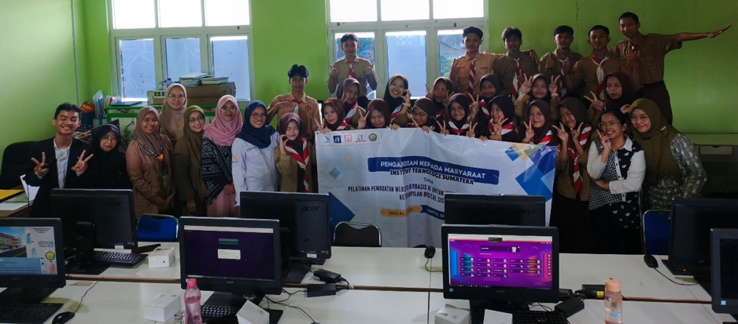
Figure 2. Documentation of Training Activity

In Figure 3, it can be seen that the speakers and committee members are assisting the participants during the training. The benefits achieved through this community service activity are that the participants now have the skills to create artificial intelligence applications easily without using coding. The improvements observed in the participants before and after the activity can be seen in the results of the questionnaire data processing, where the majority of the post-test answers were correct compared to the pre-test answers. In addition to equipping students with technical skills, this training also instilled an awareness of the importance of digitalization in the modern era. They began to understand that AI is not just a tool, but also a great opportunity to develop creativity and innovation. This awareness not only motivated them to continue learning and utilizing AI in various aspects of life but also inspired them to share their knowledge with their families and the community around them.

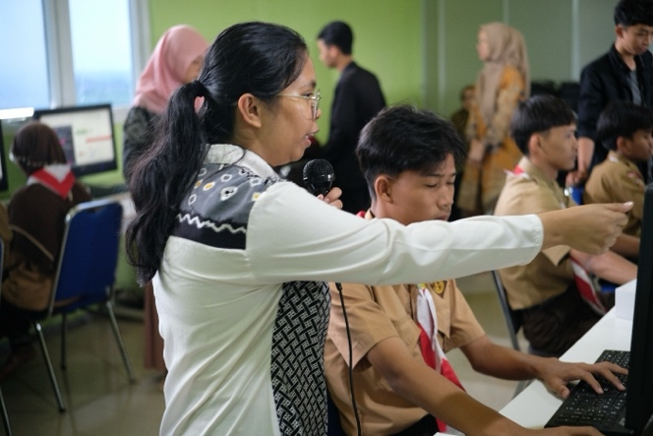
Figure 3. Documentation of Speaker’s Training

This activity also conducted a knowledge assessment of the students before (pre-test) and after (post-test) the training through an interactive quiz using Quizizz. The results of the study showed a significant improvement in the students' understanding of creating AI-based websites. Some questions from the total 10 questions in the pre-test and post-test were related to the definition of HTML, the URL function on a website, changing the appearance using JavaScript features, writing AI-based code to create websites, website development using AI, and others.
Figure 4 shows the number of people who answered questions 1 to 10 correctly. The graph clearly illustrates a noticeable improvement, with nearly all questions showing an increase in the number of participants answering correctly when comparing the pre-test and post-test results. This positive trend is particularly evident in questions 1, 3, 4, 5, 6, and 7. However, for questions 2, 8, 9, and 10, there was a slight decline in the number of correct responses between the pre-test and post-test. Overall, This activity is not only opened new perspectives for students in the digital world but also fostered a spirit of exploration and innovation. With enhanced skills and a deeper understanding, they are increasingly prepared to face challenges and contribute to technological transformation in the future.

Figure 4. The Number of People Who Answered The Question Correctly

CONCLUSION
The AI-based website development training at SMA Al Huda, South Lampung, was successfully carried out smoothly and achieved the expected objectives. Through presentations, demonstrations, hands-on practice, and interactive discussions, the students not only gained a deep understanding of website development but also received direct experience in creating AI-based websites. This program provided valuable insights for the students, particularly in the aspect of digitalization, which is expected to continue developing both in their daily lives and in the future. Additionally, this activity encouraged the students’ creativity and innovation in response to the rapid technological advancements. Thus, this training is hoped to serve as a sustainable first step in introducing AI and its applications in the digital world. It is hoped that this activity will lay a strong foundation in supporting digital transformation and inspire the students of SMA Al Huda, South Lampung, to utilize AI to enhance creativity and innovation in the technology-driven era.Provide a statement that what is expected, as stated in the "Introduction" chapter can ultimately result in "Results and Discussion" chapter, so there is compatibility. Moreover, it can also be added the prospect of the development of research results and application prospects of further studies into the next (based on result and discussion).

REFERENCES
Aprilia, W., Tabrani, M., & Fitriani, E. (2024). Workshop Artificial Intelligence Untuk Inovasi dalam meningkatkan Keahlian Masa Depan Santri Yayasan Rumah Harapan. Prawara Jurnal Abdimas, 3(2), 36–41.
Danu, A. K., Momang, H. D., Yuliantari, A. P., & Sii, P. (2024). Pelatihan Penggunaan Aplikasi Multimedia Pembelajaran Artificial Intelligency ( Ai ) Guru SMK Elanus Ruteng berbasis. Jurnal OLMA, 13(2), 907–920.
Dewi, I. K., Rahmawati, F. P., & Ghufron, A. (2024). IMPLEMENTASI KURIKULUM SEKOLAH DASAR BERBASIS PENDIDIKAN MULTIKULTURAL UNTUK MENGATASI DAMPAK NEGATIF INTERNET DAN GADGET PADA PESERTA DIDIK. Pendas : Jurnal Ilmiah Pendidikan Dasar, 9(03), 2548–6950.
Fransisca, V. J., Pratoyo, S. I., & Jati, F. L. (2024). Peningkatan Potensi dan Peran Aktif Generasi Muda dalam Organisasi Remaja Masjid terhadap Kesejahteraan Sosial di Desa Putat Lor. Indonesian Journal of Social Development, 1(4), 11. https://doi.org/10.47134/jsd.v1i4.2669
Indonesia, C. (2024). Google Ungkap 3 Sektor Paling Sering Pakai AI di Indonesia. https://www.cnnindonesia.com/teknologi/20241114071206-185-1166396/google-ungkap-3-sektor-paling-sering-pakai-ai-di-indonesia
Sahara, S., Widyastuti, R., Mailasari, M., & Puspita, A. (2024). DHARMA : Optimasi Kinerja Organisasi Karang Taruna Melalui Penerapan Teknologi Kecerdasan Buatan Artificial Intelligent DHARMA : DHARMA: Bogor Journal Of Community Service, 1(2), 13–18.
Sanggau, B. P. S. K. (2024). Optimalisasi Produktivitas Kantor dengan AI: Sesi Sharing Knowledge BPS Sanggau tentang Gemini AI. BPS. https://sanggaukab.bps.go.id/id/news/2024/09/27/59/optimalisasi-produktivitas-kantor-dengan-ai--sesi-sharing-knowledge-bps-sanggau-tentang-gemini-ai.html
Suhirman. (2009). Pembelajaran Berbasis Multimedia. Alfabeta.
Tranggono, T., Jasmin, K. J., Amali, M. R., Aginza, L. N., Sulaiman, S. Z. R., Ferdhina, F. A., & Effendie, D. A. M. (2023). Pengaruh Perkembangan Teknologi Di Era Globalisasi Dan Peran Pendidikan Terhadap Degradasi Moral Pada Remaja. Bureaucracy Journal : Indonesia Journal of Law and Social-Political Governance, 3(2), 1927–1946. http://bureaucracy.gapenas-publisher.org/index.php/home/article/view/299

* Corresponding author: Author, University, COUNTRY. email © 2021 The Author(s). Open Access. This article is under the CC BY SA license ( https://creativecommons.org/licenses/by-sa/4.0/)

