Identification of Factors Hindering the Utilization on ICT in PJOK Instruction at Elementary Schools in Tual City, Maluku Province

Rudolf Kempa | Arnold Sahalessy | Mieke Souisa*
Pattimura University,  INDONESIA | Pattimura University,  INDONESIA | Pattimura University,  INDONESIA
 | Vicktor Henry Rony Apituley
Pattimura University,
INDONESIA

Article Info |  | Abstract
Article history:  Received: Month XX, 20XX  Revised: Month XX, 20XX  Accepted: Month XX, 20XX  (Cambria 9) |  | This study aimed to examine how Information and Communication Technology (ICT) is utilized in Physical Educa.tion, Sports, and Health (PJOK) learning at elementary schools, with a specific focus on identifying the obstacles that hinder its effective implementation by teachers in Tual City, Maluku Province. This research used descriptive with a qualitative approach. The subjects of this study were 13 PJOK teachers who were selected through purposive sampling. Data were collected through observation, interviews, documentation, and triangulation. The results of the study revealed several findings: (1) the majority of teachers understand the importance of ICT in PJOK instruction, only a few actually implement it in their teaching practices; (2) internal barriers include a lack of motivation and insufficient mastery of ICT skills; and (3) external barriers comprise insufficient school support, limited facilities, and restricted internet access. In conclusion, this study found that (1) despite understanding the importance of ICT, most teachers did not fully exploit its potential in PJOK learning; (2) both internal and external factors collectively impacted the effective utilization of ICT in PJOK classrooms; and (3) the need for supporting from school authorities to collaborate with industry partners by aiming to enhance PJOK teachers’ knowledge and mastery through a variety of training programs and professional mentoring, as well as by improving the technological infrastructure that supports the teaching and learning process.
Keywords:
Identification,
Factor Hindering,
Utilization,
PJOK Instruction
To cite this article: Author. (20XX). Title. Online Learning in Educational Research, X(X), XX-XX

INTRODUCTION
Information and Communication Technology (ICT) refers to a variety of tools used to access, manage, and disseminate information. In the educational context, ICT comprises (1) hardware (such as computers, tablets, and smartphones), (2) software (including learning applications and learning management systems), and (3) communication networks (internet and intranet) (Tavares et al., 2024)) that these facilitate the enhancement of teaching and learning experiences. ICT is categorized into two major groups: first, tools that enable education and training to be carried out more effectively—not limited merely to computer technology but also including communication technologies that foster interaction between teachers and students; and second, tools that support the teaching and learning process by promoting interactive instruction and providing access to a broader range of educational resources (Barlow, 2006); (Prensky, 2001) Furthermore, integrating ICT into education not only increases the efficiency and effectiveness of learning but also opens up new opportunities for accessibility, interactivity, and personalization—features that traditional teaching methods cannot achieve (Houghton & Sheehan, n.d.); (Wahab et al., 2024).. Similarly, ICT contributes to more personalized and flexible learning, while also creating opportunities for effective collaboration among students from diverse locations (Karpliuk et al., 2024); (Kumar, 2023). This transformative potential reshapes how students learn and interact, preparing them with the necessary (Prensky, 2001).

Nowadays, the advantage of ICT has become an essential element in education. It not only facilitates broader access to information but also increases student engagement and interaction during the teaching-learning process. The learning of ICT is underpinned by the (Instruksi Presiden Republik Indonesia, Tahun 2001, n.d.), which indicates that the government recognizes the potential of telematics technology (telecommunications and informatics) to expand access and improve educational quality. This instruction mandates that such technology be integrated at the earliest possible stage, without discrimination, across all levels and types of education making telematics a crucial part of the educational system in universities, secondary, and elementary schools.

Within formal education in Indonesia from elementary through secondary levels, the term ICT is commonly referred to as TIK, an acronym for Teknologi Informasi dan Komunikasi. Previous research has identified numerous benefits of involving ICT in various subjects, including general academic subjects as well as physical education. Studies have suggested that integrating ICT can enhance children’s cognitive activities, improve self-regulation, nurture creativity, and individualize the learning process. Such integration not only enables a diverse range of activities from modelling to game-based learning but also significantly influences children’s thinking, attention, perception, and memory development (Мороз, 2024). Moreover, (ТАСКИРОВА et al., 2024); (De Oliveira Quaresma & Semeão Prazeres, 2024) also explain that ICT can enhance children's enthusiasm for learning by fostering independent knowledge acquisition and developing students’ intellectual and creative abilities, enriching the educational experiences for both children and educators, and promoting effective communication and learning skills. In the context of elementary education, particularly in the PJOK subject, ICT plays a significant role. By leveraging modern technology, teachers can present lesson materials in more engaging and interactive formats, thereby motivating students to learn.

However, despite the many advantages of ICT such as the ability to deliver visual and interactive content and facilitate wider access to educational resources, there are also several notable drawbacks. Some teachers may struggle with the technological aspects, which can impede the effective use of ICT in their classes. Additionally, infrastructural limitations such as restricted internet access and inadequate devices present significant challenges for ICT implementation in the classroom. The forms of ICT that can be utilized in PJOK learning are diverse. For example, the use of instructional videos can help clarify sports concepts in an engaging and understandable manner. Web-based learning applications (e.g., Google Classroom, various e-learning platforms) enable the management of assignments and enhance communication between teachers and students. The use of hardware such as laptops and tablets also allow teachers to present lesson materials in innovative ways.

Nevertheless, not all educational institutions or educators in Indonesia can effectively integrate ICT, particularly in subjects like physical education. This is especially true in areas classified as 3T, where infrastructure challenges are compounded by the limited availability of competent ICT skilled educators. Maluku Province, with its vast archipelagic territory of 712,480 km² consisting 92.4% water and only 7.6% land (Sitaniapessy et al., 2022); (Ratumanan et al., 2021) and divided into 11 regencies/cities with innumerable island clusters accessible primarily via sea and, more rarely, by air, exemplifies these challenges. These regencies/Province was categorized as 3T are frontier, outermost, and underdeveloped regions (Media Center Provinsi Maluku, 2022)

Tual City, an administrative city in Maluku, is located in the southeastern part of Indonesia and is situated on Tual Island. It covers an area of approximately 19,088.29 km², with land accounting for only 352.66 km² (1.33%) and sea for 18,736 km² (98.67%). The city comprises 66 clusters of small islands, of which 13 are inhabited (Wikipedia, 2024). This geographical setting significantly impacts the educational resources available, particularly human resources such as physical education teachers, who may not fully perform their professional duties owing to prove on research findings on PJOK in some regencies and City in Maluku (Anaktototy Jacob & Souisa Mieke, 2017); (Anaktototy & Souisa, 2018); (Souisa, Jacob Anaktototy, Wilhelmina Unmehopa, et al., 2020); (Souisa, Jacob Anaktototy, & Dwi Annisa, 2020); (Shela Anthonia Lekalaet et al., 2021); (Jacob Anaktototy et al., 2022); (Anaktototy et al., 2023).

In line on this research, ICT is recognized as a medium for learning. Although its use is not yet a mandatory requirement in every school throughout the archipelagic regions, creative and innovative teachers are encouraged to continuously enhance their ICT literacy. This is particularly important in subjects like PJOK that are inherently challenging to teach. When effectively employed, ICT can stimulate motivation and offer clear, efficient communication of educational information, thereby making PJOK lessons more attractive and engaging for elementary school students. The benefits of ICT for learning PJOK are (1) using Power point, (2) Instructional Videos, (3), internet, (4) Laptop, (5) goggle form application, (6) google classroom, (7) phone android (Muhammad Yaumi, 2023).

In general, (Alllen & Marrotz, 2010) assert that children aged six to twelve years exhibit unique characteristics, typically being in the concrete operational stage as described in Jean Piaget’s theory. At this stage, they begin to develop logical thinking skills, understand cause-and-effect relationships, and approach problem solving in a more systematic way. They also start to grasp the perspectives of others and develop the ability to collaborate within groups. Furthermore, their capacity to organize information and engage in abstract thinking starts to develop, although it remains limited. Consequently, since children in this age range are indeed at the elementary education level, integrating Information and Communication Technology (ICT) into the learning process can undoubtedly increase student motivation and challenge, thereby enabling them to more rapidly absorb the knowledge being taught (Latip 2021 as cited in (Jamun et al., 2023)). This approach is clearly aligned with the overarching goal of utilizing ICT in education, which is to overcome various barriers in the transfer of information and the facilitation of communication between educators and students. These barriers include obstacles arising from physical, psychological, socio-cultural factors, and environmental conditions (Widianto, 2021).

However, the effective utilization of ICT in education certainly requires educators to possess solid ICT literacy in line with their respective fields of expertise. The fact remains that not all educators currently understand or master ICT sufficiently to integrate and apply it in the planned and implemented learning processes. As stated by Gatot Suhartowo (Head of the Center for Information and Communication Technology in Education and Culture at the Ministry of Education and Culture), only 40% of the total number of teachers in Indonesia are currently proficient in information and communication technology (Sanusi 2019 as cited in (Jamun et al., 2023)). This underscores that many teachers in Indonesia still lack ICT proficiency, primarily due to limited exposure to science and technology.

In line with the importance of the role of ICT in the PJOK learning process and various previous research findings that show challenges in the field, this study aims to identify factors that hinder the use of ICT in PJOK learning at the elementary school level in Tual City. Thus, the results of this study are expected to provide a real contribution to the development of the quality of PJOK learning, especially in island areas such as Tual City, and more broadly become a reference for improving the quality of learning in other districts/cities in Maluku Province

METHOD
This research was a descriptive study that aimed to depict the phenomenon or condition regarding the ability of Physical Education, Sports, and Health (PJOK) teachers to utilize Information and Communication Technology (ICT) in learning. It employs a qualitative approach that focuses on the meanings, experiences, and subjective understandings of the participants, who serve as subjects of this study. In this research, the subjects were selected purposively and consisted of 13 PJOK teachers. These teachers were local educators who possess an understanding of the characteristics of the students in the area and had an average tenure of 10 years. They were drawn from 13 public elementary schools in Tual City, which was the location of this study. By an average teaching experience of 10 years, these subjects naturally had relevant expertise and practical experience as PJOK teachers, thereby providing authentic and pertinent data for the objectives of this research.

The data collection techniques employed in this study consisted of the following: (1) observation, (2) documentation, (3) interviews, and (4) triangulation. Observation is a data collection method that involves systematically watching the phenomenon or behaviours related to the utilization of ICT in PJOK learning, without any direct intervention by the researcher. In this study, the researcher applied “participant observation,” meaning that the researcher actively engaged in the learning activities to closely observe the instructional process conducted by the subjects. Documentation involves collecting written documents, photographs, video recordings, archives, or other supporting data relevant to the research. For this study, documentation was carried out by gathering lesson plans or teaching modules provided by the subjects. Interviews were a technique for collecting data through direct conversations between the researcher and the respondents to obtain in-depth information about the utilization of ICT in PJOK learning. The interviews were conducted in a semi-structured format; the questions were identified according to the research objectives and were allowed to develop further in response to the conditions encountered in the field. Triangulation is a strategy for enhancing data validity by comparing and confirming findings from various sources or methods. In this research, method triangulation was applied, which entails using or combining several data collection techniques in order to cross-check the data collected through observation, documentation, and interviews (Sugiyono, 2013b). A more detailed illustration of the data collection techniques used in this study can be seen in Figure 1 below.
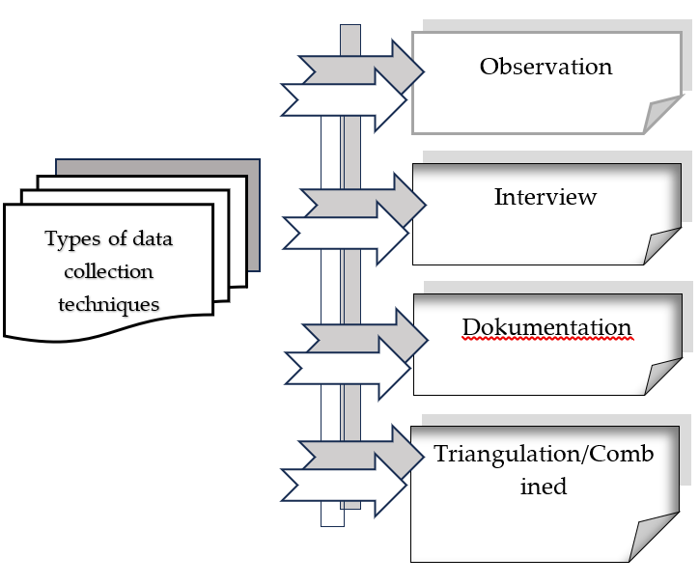

Figure 1. Various data Collection techniques
Source: (Sugiyono, 2013a)
To make easy the process of qualitative data analysis in this research, the researcher used a “Flow Models analysis,” which consisted of three simultaneous activity flows: data reduction, data display, and drawing conclusions or verification, as described by Miles & Huberman (1984) in (Prastowo, 2011), as illustrated in Figure 2. Thus, by using the flow model, the study was capable of describing the three main indicators in this research, namely: (1) the subjects’ understanding related to the utilization of ICT, (2) the utilization of ICT in the context of PJOK learning, including the various forms of ICT utilization in PJOK learning, and (3) the factors that hinder the utilization of ICT in PJOK learning.
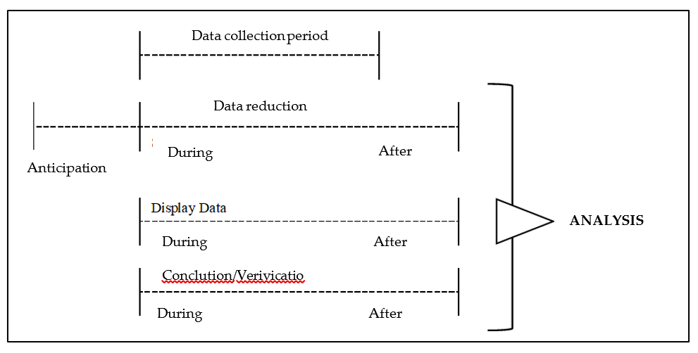

Figure 2. Components in data analysis
Source: (Prastowo, 2011)

RESULTS AND DISCUSSION
The results found based on data obtained from 13 subjects, with 3 (three) main indicators, namely; (a) subject understanding of ICT, (b) forms of ICT utilization in PJOK learning, (c) Challenges faced by subjects in utilizing ICT in learning. These three indicators can be described as follows:

Understanding of research subjects related to “utilization of ICT in learning
The first indicator is intended to determine the basic understanding of the concept of ICT, so the basic question is given to the subject "does the subject understand the general concept of ICT?". Based on this question, 69.2% of subjects responded that they knew and understood the concept of ICT, but in contrast to 30.8% of subjects who admitted "did not understand ICT". The subject's response can be seen in Figure 3.
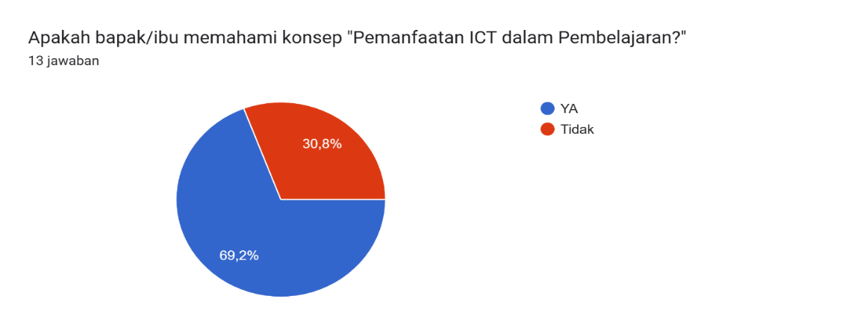
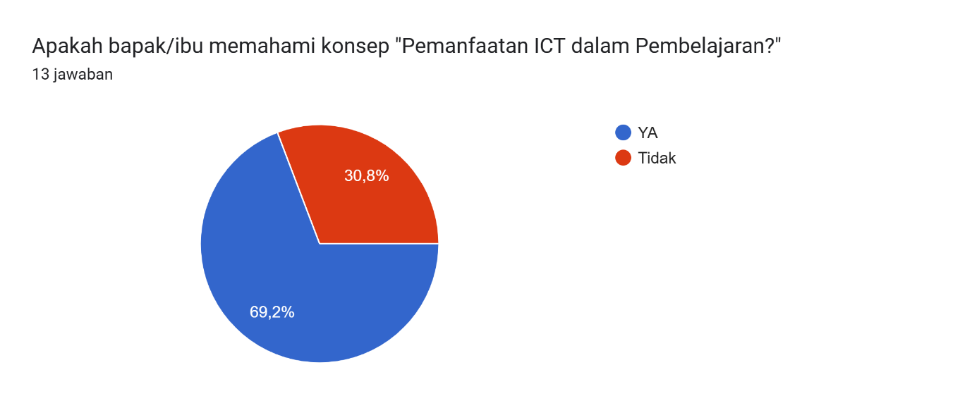
Yes
No

Figure 3. Research subjects' understanding of the concept of ICT

Forms of ICT Utilization in the context of PJOK learning.
The second indicator aims to find out whether the concept of ICT in learning can also be utilized in learning Physical Education, Sports and Health (PJOK), and what are the forms of ICT utilization in PJOK learning. So based on the 2 (two) sub-indicators, the data obtained can be seen in diagrams 2 and 3, which can be described as follows:
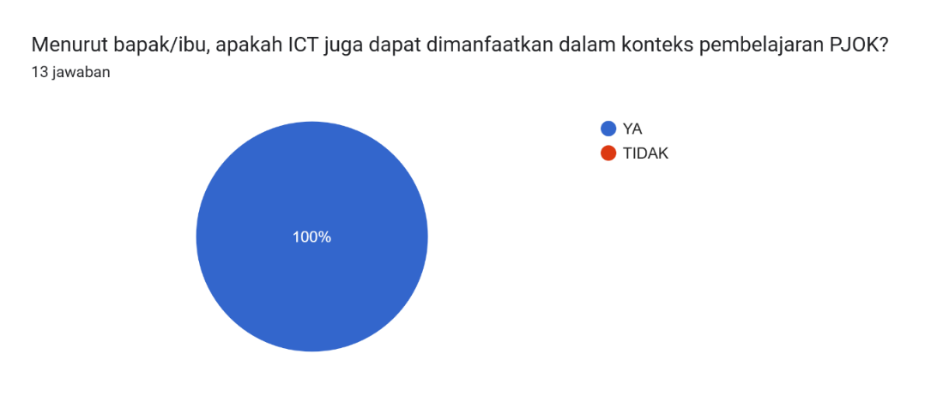
Yes
No

Figure 4. Subjects' Responses on the Use of ICT in PJOK Learning

Based on Figure 4 above, 100% of research subjects responded in agreement that ICT can be utilized in Physical Education, Sports and Health (PJOK) learning. Furthermore, to prove the truth of the research subject's response to the first indicator and the second indicator, especially in the first sub-indicator, then in this second sub-indicator, the researcher provides 7 (seven) forms of ICT utilization used in general learning, which are often also used in Physical Education, Sports and Health learning. The seven forms include; (1) Teaching in class with power point to clarify the teaching material, (2) Showing learning videos for students, according to the learning material, (3) Utilizing the internet to explore the material, (4) Using laptops in theoretical learning, (5) Utilizing the google-form application for learning evaluation, (6) Utilizing Google Classroom, to send learning assignments, (7) Utilizing android phones, for learning.
Based on the seven forms of ICT utilization in learning in general, and PJOK in particular, the data obtained is as shown in Figure 5.

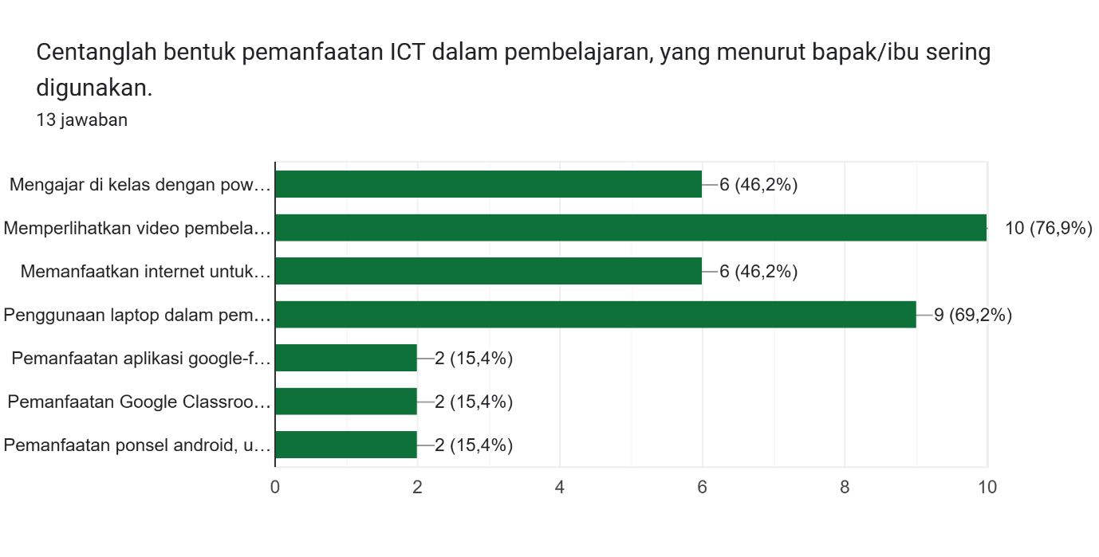
Teaching in class with..
Showing learning video..
Utilizing the internet to..
Using Laptops in theore..
Utilizing the google-form..
Utilizing google classroo...
Utilizing android phones..

Figure 5. Forms of ICT often used by subjects in PJOK learning

Based on the subject responses depicted in diagram 3 above, it can be explained that for the first form "Teaching in class with power point to clarify teaching materials", then 46.2% of the total subjects or as many as 6 subjects use power point to clarify teaching materials in learning. For the second form, namely "Showing learning videos for students, according to learning materials", 76.9% of the total subjects or as many as 9 subjects utilize learning videos for students according to learning materials. For the third form, "Utilizing the internet to explore materials", then 46.2% of the total subjects or 6 subjects utilize the internet to explore learning materials. For the fourth indicator "Use of laptops in theoretical learning", then 69.2% of the total subjects or as many as 9 subjects use laptops in theoretical learning. For the fifth indicator "Utilization of the google-form application for learning evaluation", it turns out that only 15.4% of the total subjects or only 2 subjects utilize google-form for learning evaluation. For the sixth indicator "Utilization of Google Classroom, to send learning assignments", it turns out that only 15.4% of the total subjects or 2 subjects only use Google Classroom to send learning assignments from students. and the seventh form, namely "Utilization of Android phones, for learning", it turns out that only 15.4% of the total subjects or as many as 2 subjects often use Android phones for learning.
Challenges faced by research subjects when utilizing ICT in PJOK learning.
Based on the data obtained in the second indicator that has been discussed in the previous section, then in this third indicator, the question aims to explore the challenges faced by all research subjects when utilizing ICT, so that both those who often utilize ICT and those who do not utilize ICT in PJOK learning. The responses of research subjects can be classified into 3 (three) categories, namely;
- As big as 7% of subjects did not experience challenges;
- As big as 77% of subjects experienced challenges both internally and externally;
- As big as 16% gave floating responses, where the answers were not in line with the questions asked.
Each category of research subject responses that will be described is those who face challenges of 77%.
The challenges faced by the subjects are internal and external. The internal challenges faced by the subjects are as follows:
- Self, namely "still lazy to look for information about ICT that can help the PJOK learning process".
- Minimal mastery of ICT, so that when trying to utilize ICT in learning, always encounter obstacles that cannot be overcome alone.
- Do not understand ICT, even though they already know the benefits of its forms, but do not understand how to operate it.
Furthermore, the external challenges faced by subjects in utilizing ICT in PJOK learning mostly originate from infrastructure, including:
  - The school does not have facilities that can support the use of ICT.
  - The internet network cannot be accessed properly (slow), as it should be in the city center in general.
  - The school does not pay enough attention to supporting facilities and infrastructure for theoretical learning.
  - The school never requires teachers to use ICT in the learning process.
  - Power often goes out, which also affects the use of ICT.
  - Students do not understand the use of technology well.
Meanwhile, for the category of no challenges amounting to 7%, where the subjects are accustomed to utilizing ICT in PJOK learning, so they do not experience obstacles. Meanwhile, the floating response amounting to 16% is due to questions addressed to others, while the responses given are not in line with the questions, or in other words do not understand the concept of ICT in learning.
Information and Communication Technology (ICT) played an important role in the school learning context not only as an assistive tool, but also as a connector that could broaden access and enhance interaction between students and teachers, as well as serve as a medium to clarify various educational information. The utilization of ICT in general learning and in Physical Education, Sports, and Health (PJOK) instruction followed the developments of Industry 4.0 technology that had permeated the education sector. This technological advancement challenges teachers to consciously developed themselves and innovated in order to provide engaging, enjoyable, and challenging learning experiences, thus motivating students to actively participate in the learning process.
Based on the objectives of this study which were to analyse the utilization of ICT and to identify various challenges in PJOK instruction at the elementary school level by teachers in Tual City, Maluku Province and drawing on the data described in the preceding section, it could be stated that as an administrative city in an archipelagic province, Tual is also categorized as a 3T region (far from the provincial capital, with limited infrastructure and difficult to reach within a short time). Moreover, the challenging natural conditions further complicated the equitable development of infrastructure, which in turn also impacted the field of education.
The research findings presented in the previous section indicate that 69.2% of the study subjects understood the concept of utilizing ICT in PJOK instruction, while 30.8% did not. This suggests that although a majority of the subjects recognized the need for ICT in PJOK instruction, there remained a group that did not fully comprehend its importance. Consequently, there was a need for further training and outreach regarding ICT and its application in PJOK instruction. These findings are in line with the study conducted by (Irwahand et al., 2022), which revealed that a significant number of physical education teachers have not yet comprehended or implemented ICT in their instructional activities. Therefore, it was essential for schools and local governments, through their educational departments, to provide support in the form of workshops or seminars. Such initiatives would enable all teachers to understand the benefits of ICT and how to implement it effectively in the learning process, especially in PJOK. These findings aligned with the research conducted by (AYUNAR et al., 2024); (Cabunoc & Ubayubay, 2024); which examines the factors influencing ICT competency among public school teachers in Bukidnon. Their study aims to identify the main determinants of ICT competency and offers recommendations for enhancing technology integration in education, concluding that professional training and support are necessary to improve teachers’ ICT skills.
Regarding the utilization of ICT in PJOK instruction, the research results showed that 100% of the respondents agreed that ICT could be utilized in the PJOK learning process. This indicates a high level of awareness among teachers regarding the importance of technology in enhancing the teaching and learning process. Because, ICT utilization could improve interaction and the appeal of learning materials, as well as facilitate a more dynamic and effective learning process. Based on the data obtained concerning the forms of ICT frequently used by the subjects in PJOK instruction (analysed qualitatively through questionnaires, observation, interviews, and documentation), the following could be stated. As with other subjects, the research subjects who were PJOK educators—often conduct their lessons using the following methods: (1) Displaying instructional videos, at a rate of 76.9%. This figure indicated that most subjects are aware of the importance of visualization in explaining PJOK concepts through video presentations related to the learning material. However, this was contradicted by the researchers’ observations during classroom instruction, where only a small fraction of subjects displayed instructional videos, whereas the majority did not. When confirmed during interviews, some subjects explained that the family’s laptop was concurrently used, preventing them from displaying videos in accordance with the lesson content during observations; some even encountered difficulties in preparing videos related to the teaching material. (2) Using laptops, at a rate of 69.2%. This indicates that most subjects frequently used visual aids such as laptops to clarify teaching material during the learning process; the intent is to enhance the clarity of PowerPoint presentations and video screenings via laptops with the aid of Liquid Crystal Display (LCD) projectors. Although there was scope for increasing the use of additional devices, observational evidence suggests that not all subjects use laptops. Some cited reasons similar to those mentioned in the previous point, including the fact that some did not possess a laptop due to various considerations related to family needs. (3) Utilizing PowerPoint, at a rate of 46.2%. This figure showed that only some subjects often utilize Microsoft Office (PowerPoint) to clarify the learning material. While Microsoft offered many options, most of which require an internet connection for access or specialized skills related to digital literacy, PowerPoint itself could be readily accessed without an internet connection. Therefore, if an educator is unable to utilize PowerPoint, it may indicate that their “digital literacy is severely limited or low.” Today, PowerPoint is a commonly used application, and many students could operate it proficiently. This was evidenced during field observations, where only a portion of instructors used PowerPoint to display videos, with most opting to conduct lessons directly in the field rather than in the classroom. (4) Using the internet, at a rate of 46.2%. This figure demonstrates that only some of the research subjects frequently used the internet to explore materials, reflecting the initiative of teachers to seek additional relevant information for their students. However, others did not utilize the internet in the learning process. In practice, the internet could be leveraged to access online materials or to conduct learning evaluations. Interview results further revealed that in addition to the absence of WiFi at the schools where teachers instruct, some subjects did not know how to operate a mobile hotspot. Additionally, even when the internet was to be used, it sometimes was not supported by uninterrupted electricity—as power outages often occurred during instructional periods—which greatly affected the use of supplementary learning media. (5) Utilizing Google Classroom (GC), at a rate of 15.4%. Despite GC being one of the long-used media in education and beneficial for discussion outside of class hours, only a small fraction of the subjects employed GC in PJOK instruction, while the majority did not. (6) Utilizing Google Form, at a rate of 15.4%. This low figure indicated that the use of the Google Form application in PJOK instruction is very minimal, even though Google Form represents a simple digital platform for supporting the main evaluation tasks of the subjects. (7) Using Android smartphones, at a rate of 15.4%. The low usage rate of Android smartphones in PJOK instruction is notable, particularly given that today, from children to adults, most people used Android smartphones as the primary means of communication.
Generally, the utilization of ICT in PJOK instruction, as described in the previous section, is influenced by challenges that served as the primary barriers to its effective use. The research found that 7% of the subjects did not experience any hindrance in utilizing ICT, 77% encountered challenges both internal and external and 16% provided ambiguous responses. These responses could be categorized as follows:
Internal Factors:
Obstacles such as low motivation and inadequate mastery of ICT indicate that there is a need to develop teacher capacity through continuous training, thereby boosting their confidence in using technology.
External Factors:
Limited support from the school, inadequate facilities, and restricted internet access are significant issues. It is imperative that schools pay attention to ICT infrastructure and create policies that encourage teachers to incorporate technology into their teaching.
Ambiguous Responses:
A small portion of subjects provided unclear responses, which may indicate a lack of understanding of ICT (similar to responses observed for the first indicator discussed in the research findings), thus necessitating further guidance and mentoring to clarify the role of ICT in PJOK instruction. More intensive support and mentoring from the schools could help alleviate this confusion.
These research outcomes are further supported by previous studies by (Anastasopoulou et al., 2024); (Boruah, 2022); (Fathima et al., 2024); (Firdaus & Ritonga, 2024); (Koshti et al., 2023); (Mahmudah et al., 2023); (Meriyanti & Jasmina, 2022); (Rakshak Bharti et al., 2024); and (Sambul et al., 2024), which have discussed several impacts of ICT implementation in education, including; (1) Limited Access to Information; Without ICT, both students and teachers may experience difficulties in accessing a broader array of information and learning resources. This limitation can hinder the development of knowledge and the broadening of perspectives necessary in education. (2) Restricted Interaction; ICT facilitates improved communication and interaction between students and teachers, as well as among students themselves. Without technological support, these interactions become limited, potentially affecting student motivation and engagement in the learning process. (3) Lower Quality of Instruction; ICT can enhance the quality of instruction through more innovative and interactive teaching methods. Without it, traditional methods that may be less engaging could lead to poorer learning outcomes. (4) Difficulties in Distance Learning; This is particularly problematic in archipelagic regions, where logistical challenges often impede direct educational access. Without ICT, distance education or online learning may be unavailable, resulting in inadequate educational opportunities for students in remote areas. (5) Educational Inequity; Regions that do not capitalize on ICT risk exacerbating educational inequities compared to more advanced areas. This could worsen disparities in access to education and future opportunities. (6) Deficient and Deteriorating Digital Skills; In today’s digital era, technological skills are increasingly important. Without ICT integration in learning, students might lack the digital skills necessary to compete in a technology-driven job market. (7) Limited Creativity Development; ICT provides a platform for students to be creative and express themselves through various media. Without access to such technology, opportunities for creative exploration in learning may be significantly restricted. Similarly, research by (Zulkifli et al., 2024) concluded that “increasing telecommunications infrastructure, improving digital literacy among teachers and students, and fostering closer collaboration between the government and industry are critical to addressing the various challenges or issues faced in Physical Education instruction more effectively.”
Based on these research findings, several important considerations warrant attention from stakeholders such as local governments and industry partners: (1) If ICT was not utilized in the learning process in general and in PJOK instruction in particular especially in Tual City, Maluku Province, it would have a negative impact on students. (2) Although there were strategic plans for the development of archipelagic human resources and infrastructure, the actual implementation of instruction in the research location faces significant challenges that are not aligned with these strategic plans.

CONCLUSION
This study demonstrates that most Physical Education (PJOK) teachers in the Maluku archipelago possess a sound understanding of the importance of integrating Information and Communication Technology (ICT) into the learning process. However, only a limited number of them actively utilize ICT in classroom instruction. The primary inhibiting factors are both internal—such as low intrinsic motivation and limited ICT proficiency—and external, including insufficient institutional support, inadequate technological facilities, and limited internet connectivity. Optimizing the integration of ICT in PJOK learning requires comprehensive efforts, including strengthening institutional support, providing continuous professional development, enhancing infrastructure, and offering structured mentoring to build teachers’ digital competence and confidence. Encouraging PJOK teachers to embrace technology is a strategic step toward improving the overall quality of basic education, particularly in geographically isolated regions. This study is limited in scope, as it focuses only on selected areas within the Maluku province. The data collected were predominantly based on teachers’ perceptions and self-reports, without in-depth observation of ICT implementation in classroom settings. Therefore, the generalizability of the findings to other regions with differing geographical or institutional conditions is limited. From a theoretical perspective, this study contributes to the growing discourse on the integration of digital technology in physical education, particularly within the context of remote island regions. It reinforces the notion that the success of educational digitalization is not solely dependent on infrastructure availability but also on human factors, such as teacher readiness and institutional commitment. The study offers valuable insights for developing locally contextualized strategies for digital transformation in education. Future research is recommended to explore more comprehensively the perspectives and readiness of broader stakeholders, including school leaders, education authorities, and educational technology providers, in supporting the integration of ICT in teaching. Employing experimental or developmental research methods may also provide a clearer assessment of the effectiveness of professional training programs and intervention strategies aimed at enhancing teachers’ ICT competencies and motivation.

REFERENCES
Alllen, K. , E., & Marrotz, L. R. (2010). Profil Perkembangan Anak. Pra Kelahiran Hingga Usia 12 Tahun (Valentino, F. I. Dewi, B. Sarwidji, Y. Mulianto, & D. K. Ria, Eds.; 1st ed.). PT. Indeks.
Anaktototy, J., & Souisa, M. (2018). The Analisys of Ability Physical Education Teachers in Managing Learning at The Level of a Junior High School in The Ambon City (T. Laurens & S. Unwakolly, Eds.; pp. 196–202). Fakultas Keguruan dan Ilmu Pendidikan, Universitas pattimura.
Anaktototy, J., Souisa, M., Syaranamual, J., & Lambiombir, A. M. M. (2023). Efektivitas Model Pembelajaran PBL dalam Meningkatkan Hasil Belajar Menganalisis Variasi Keterampilan Bermain Bola Basket Siswa Kelas X SMAN 7 Maluku Tengah.
Anaktototy Jacob, & Souisa Mieke. (2017). The Mapping of Elementary Students Basic Motor Skill at Ambonnes City (Arjanto Paul, Ed.; pp. 84–96). Fakultas Keguruan dan Ilmu Pendidikan - Universitas Pattimura.
Anastasopoulou, E., Angeliki Tsagri, Eleni Avramidi, Konstantina Lourida, Evangelia Mitroyanni, Danai Tsogka, & Ioannis Katsikis. (2024). The Impact of ICT on Education. Technium Social Sciences Journal, 58, 48–55. https://doi.org/10.47577/tssj.v58i1.11144
AYUNAR, G. S., CASILDO, N. J. G., TALANDRON-FELIPE, M. M. P., BONIFACIO, K. L. A., SEBUGUERO, F. S., & MARCELO, J. G. (2024). Determinants of ICT Competency Among Public School Teachers in Bukidnon. International Conference on Computers in Education. https://doi.org/10.58459/icce.2024.4991
Barlow, J. (2006). The Role of ICT in Education. Routledge.
Boruah, N. (2022). Impact of ICT in education. International Journal of Health Sciences, 1818–1822. https://doi.org/10.53730/ijhs.v6nS2.5397
Cabunoc, C. F. L., & Ubayubay, R. M. (2024). Competency and Barriers in Using ICT among Public School Teachers in Tagoloan District. INTERNATIONAL JOURNAL OF MULTIDISCIPLINARY RESEARCH AND ANALYSIS, 07(08). https://doi.org/10.47191/ijmra/v7-i08-14
De Oliveira Quaresma, D., & Semeão Prazeres, I. (2024). USE OF INFORMATION AND COMMUNICATION TECHNOLOGIES (TICS) AS PLAY TOOLS TO MEDIATE THE LEARNING OF ELEMENTARY SCHOOL CHILDREN - II. Revista Gênero e Interdisciplinaridade, 5(01), 76–88. https://doi.org/10.51249/gei.v5i01.1847
Fathima, G., Sree, J. R., Rani, K. S., Kiran, S., & Jasmin, N. (2024). Rural Edurevamp. Computer Science, Engineering and Technology, 2(1), 6–12. https://doi.org/10.46632/cset/2/1/2
Firdaus, K., & Ritonga, M. (2024). Peran Teknologi Dalam Mengatasi Krisis Pendidikan di Daerah Terpencil. Jurnal Kepemimpinan Dan Pengurusan Sekolah, 9(1), 43–57. https://doi.org/10.34125/jkps.v9i1.303
Houghton, J., & Sheehan, P. (n.d.). A Primer on the Digital Economy. AusInfo.
Instruksi Presiden Republik Indonesia, Tahun 2001.
Irwahand, F. N. E., Mat-Rasid, S. M., Lee, J. L. F., Elumalai, G., Shahril, M. I., & Ahmad, M. A. I. (2022). Perceived barriers to adopting information and communication technology in physical education. Pedagogy of Physical Culture and Sports, 26(5), 291–299. https://doi.org/10.15561/26649837.2022.0503
Jacob Anaktototy, Mieke Souisa, & Jusak Syaranamual. (2022). Evaluasi Kemampuan Guru PJOK Mendesain Rencana Pelaksanaan Pembelajaran pada Jenjang Sekolah Menengah Atas di Kota Ambon. SPRINTER: Jurnal Ilmu Olahraga, 3(3), 179–188. https://doi.org/10.46838/spr.v3i3.250
Jamun, Y. M., Ntelok, Z. R. E., & Ngalu, R. (2023). Pentingnya Penggunaan Teknologi Informasi dan Komunikasi dalam Menunjang Pembelajaran Sekolah Dasar. EDUKASIA: Jurnal Pendidikan Dan Pembelajaran, 4(2), 2149–2158. https://doi.org/10.62775/edukasia.v4i2.559
Karpliuk, S., Moyseyenko, I., Lysenko, T., Moroz, O., & Protas, O. (2024). The role of ICT in education: Comparing virtual and traditional learning methods. Multidisciplinary Reviews, 8, 2024spe068. https://doi.org/10.31893/multirev.2024spe068
Koshti, R., Fatima, S., & Jain, R. (2023). The Role and Impact of Information and Communication Technologies (ICT) in 21st Century Education. 2023 IEEE International Conference on ICT in Business Industry & Government (ICTBIG), 1–5. https://doi.org/10.1109/ICTBIG59752.2023.10456031
Kumar, P. (2023). Transformative Role of ICT in 21st Century Learning: Enhancing Educational Effectiveness and Equitability. International Journal for Research in Applied Science and Engineering Technology, 11(12), 91–95. https://doi.org/10.22214/ijraset.2023.57028
Mahmudah, E., Ni’maturahmah, B., & Dewi, D. A. M. (2023). Utilization of Information and Communication Technology as Learning Media to Improve the Quality of Education in Elementary Schools. Social, Humanities, and Educational Studies (SHES): Conference Series, 6(1), 358. https://doi.org/10.20961/shes.v6i1.71137
Media Center Provinsi Maluku. (2022, March 31). Gubernur Harap Daerah 3T di Maluku Dapat Berkembang Sejajar Dengan Daerah Lain di Indonesia. Https://Mediacenter.Malukuprov.Go.Id/Gubernur-Harap-Daerah-3t-Di-Maluku-Dapat-Berkembang-Sejajar-Dengan-Daerah-Lain-Di-Indonesia/.
Meriyanti, M., & Jasmina, T. (2022). Access of Information, Communication, and Technology (ICT) and Learning Performance of Junior High School Students in Indonesia: Analysis at the District Level. Jurnal Perencanaan Pembangunan: The Indonesian Journal of Development Planning, 6(3), 304–326. https://doi.org/10.36574/jpp.v6i3.267
Muhammad Yaumi. (2023). Media dan Teknologi Pembelajaran (S. F. S. Sirate, Ed.; Kedua). Kencana, Prenamedia Group.
Prastowo, A. (2011). Metode Penelitian Kualitatif; dalam Perspektif Rancangan Penelitian. Departemen Pendidikan Nasional.
Prensky, M. (2001). Digital Natives, Digital Immigrants. On The Horizon, 9(5).
Rakshak Bharti, Kasturi Pomal, Mariyam Ahmed, & Chandra Bhooshan Singh. (2024). Transformative Impact of ICT on Education: Leveraging Technology and Communication to Enhance Teaching and Learning. Feedback International Journal of Communication, 1(3), 131–141. https://doi.org/10.62569/fijc.v1i3.39
Ratumanan, T. G., Wenno, I. H., Laurens, T., Salakory, M., Kempa, R., Mataheru, W., marantika, J. E. , R., Papilaya, P. M., Smith, A., & Tutuarima Fricean. (2021). Pendidikan Kepulauan: Vol. ISBN: 9786233721981 (T. G. Ratumanan, F. Tutuarima, D. Aprilyani, & Jaenudin, Eds.; Cetakan Pertama). PT. RajaGrafindo Persada.
Sambul, A., Rumbayan, M., Kindangen, J. I., Sompie, S. R. U., & Cross, J. (2024). Wireless Education Delivery System for Remote Island Communities Utilizing Maritime Data Carriers. 2024 6th International Conference on Computer Communication and the Internet (ICCCI), 223–226. https://doi.org/10.1109/ICCCI62159.2024.10674264
Shela Anthonia Lekalaet, Mieke Souisa, & Jacob Anaktototy. (2021). SURVEI PENILAIAN PSIKOMOTOR DALAM PEMBELAJARAN PENJAS DIMASA PANDEMI COVID-19 PADA SISWA KELAS XMia SMAN 8 AMBON. Jurnal Kejaora (Kesehatan Jasmani Dan Olah Raga), 6(2), 233–242. https://doi.org/10.36526/kejaora.v6i2.1512
Sitaniapessy, A., Usmanij, P., & Ratten, V. (2022). Survivability of MSMEs in Maluku: An Analysis on Challenges, Opportunities and Strategic Development. In V. Ratten, P. Jones, V. Braga, & E. Parra-López (Eds.), Artisan Entrepreneurship (pp. 87–98). Emerald Publishing Limited. https://doi.org/10.1108/978-1-80262-077-120221010
Souisa, M., Jacob Anaktototy, & Dwi Annisa. (2020). KEMAMPUAN GURU PENJASOR MENERAPKAN KURIKULUM 2013 DALAM PEMBELAJARAN PADA SISWA KELAS X SMAN 3 SALAHUTU. Jurnal Kejaora (Kesehatan Jasmani Dan Olah Raga), 5(1), 50–56. https://doi.org/10.36526/kejaora.v5i1.856
Souisa, M., Jacob Anaktototy, Wilhelmina Unmehopa, Mariana Hukubun, Emma Rumahlewang, Jonas Solissa, & Johana Matitaputty. (2020). Curriculum 2013 Implementation Workshop Curriculum 2013 In Learning In The District of Babar Islands – Southwestern Maluccas Regions. GANDRUNG: Jurnal Pengabdian Kepada Masyarakat, 1(2), 25–36. https://doi.org/10.36526/gandrung.v1i2.932
Sugiyono. (2013a). Memahami Penelitian Kualitatif (VIII). Alfabeta.
Sugiyono. (2013b). Memahami Penelitian Kualitatif. Dilengkapi contoh proposal dan laporan penelitian. (Kedelapan). Alfabeta.
Tavares, P. R., Pereira, D. A. de S., De Brito, F. C., De Sá, G. B., Gomes, L. F., Fujiyoshi, M. R. dos S., Modesto, V. T., & Da Cruz, R. C. das V. (2024). The role of digital information and communication technologies in modern education. CONTRIBUCIONES A LAS CIENCIAS SOCIALES, 17(2), e4980. https://doi.org/10.55905/revconv.17n.2-015
Wahab, G., Susanto, S., & Kalukar, V. J. (2024). Transforming Education for the Future: Integrating Technology and Personalized Learning. International Journal of Social and Human, 1(3), 278–285. https://doi.org/10.59613/jmqd4d14
Widianto, E. (2021). Pemanfaatan Media Pembelajaran Berbasis Teknologi Informasi. Journal of Education and Teaching, 2(2), 213. https://doi.org/10.24014/jete.v2i2.11707
Wikipedia. (2024, September 1). Luas Wilayah Kota Tual. Https://Id.Wikipedia.Org/Wiki/Kota_Tual.
Zulkifli, Henjilito, R., Makorohim, M. F., Yani, A., & Alficandra. (2024). A content analysis on the challenges experienced in implementing technology in physical education in Indonesia. Edu Sportivo: Indonesian Journal of Physical Education, 5(3), 258–273. https://doi.org/10.25299/esijope.2024.vol5(3).18254
Мороз, О. (2024). ОСОБЛИВОСТІ ВПРОВАДЖЕННЯ ІНФОРМАЦІЙНО-КОМУНІКАЦІЙНИХТЕХНОЛОГІЙ У ОСВІТНІЙ ПРОЦЕС МОЛОДШИХ ШКОЛЯРІВ. Modern Information Technologies and Innovation Methodologies of Education in Professional Training Methodology Theory Experience Problems, 70, 66–74. https://doi.org/10.31652/2412-1142-2023-70-66-74
ТАСКИРОВА, З. Ш., САНГАДЖИЕВ, Б. В., БАДМАЕВА, А. О., КИТАЕВ, М. Ю., ПЮРБЕЕВ, С. В., НИКУЛИН, О. А., & КИТАЕВ, Б. Е. (2024). THE ROLE OF INFORMATION AND COMMUNICATION TECHNOLOGIES IN THE LEARNING PROCESS OF CHILDREN. Экономика и Предпринимательство, 1(162), 1182–1185. https://doi.org/10.34925/EIP.2024.162.1.228

